# Introduction

## 1.1 Introduction to the system

**“Doctor Information system”** provides information of the doctors available in our locality. It is web-based information system. I have used Laravel framework for the development of this project. It will add information of doctor in near area and update and delete information if needed by admin. User can able to select location and get information of doctor available. User could able to provide feedback after services provided by doctor.

## 1.2 Background of the system

This will be the new project. Reason behind choosing the Laravel framework for the development of the project is it provide more flexibility, structure, efficient, easier for the development. It has exception handling properties which helps to

The main reason for choosing this project is many of people faces a lot of problems because of lack of information of doctors. They travel more in search of doctor for the treatment of disease. They could be able to find doctor information in one click.

## 1.3 Aim and objectives

**Aim:**

Provide reliable source of information of doctor available in locality

**Objectives:**

* To make the Effective system
* To make easier interface
* To Increase efficiency
* To increase the Availability
* To provide Reliable information
* To reduce the cost
* To save the time

## Features

* Provide easier interface for login users
* User could be able to provide feedback
* Contact doctor with email
* Take the appointment
* Get information of the doctor’s specific degree
* Able to provide rating to the doctor after they provide facility
* Comment on the posts
* Update profile
* Easily register
* Login attempt
* Doctor could be able add post and delete their own posts
* User could be able add some query on the web application

## 1.5 Justification of project

It will reduce the cost of travelling and search for doctor by seeing the people chooses of given rating. It will save time too. It will increase the dependency on technology. Since it has easier interface so will provide efficiency. Since it is cost, time effective project it will be appropriate to do.

## 1.6 Overview of the purpose of the system

It will be simple and informative information system. It will be cost reducing and time reducing product. It will motivate people to use technology.

# Chapter 2: Analysis

It consists of different subtopic which are mention below:

1. Introduction
2. Analysis methodology
3. Feasibility study
4. Information gathering
5. Software requirement Specification
6. Use case
7. System Architecture

## 2.1 Introduction:

Analysis is the process of gathering and specifying the requirement on the basis of the priority of that function, identifying the problems and split into parts/ components so that it can be easily solved.

It is conducted for the purpose of studying the products/ systems or its parts in order to find out the objectives. In other hand it helps to improve the system and make sure that all the parts of the system work effectively to accomplish their purpose. It specifies what are function should be in the system and what the system should perform.

Survey

Questioner

Economical

Object oriented analysis

System architecture

Use-case diagram

SRS

MoSCoW

Non functional

Functional

Time

Legal

Technical

Ethical

Analysis methodology

Feasibility study

Information gathering

Requirement specification

Use case and system architecture

## 2.2 Analysis methodology (Object oriented Methodology)

For the analysis methodology I have used object-oriented analysis. Object-oriented analysis is technical approach of analysis of system or application by the use of object-oriented paradigm and visual modeling. It does not only focus on the process or data of the system but view the system or application as a collection of interacting objects which works together to perform certain task.

Object-oriented analysis uses three analysis techniques which are given below:

1. Object modeling
2. Functional modeling
3. Dynamic modeling

### 2.2.1 Object modeling

It identifies objects, classes, their relationships and methods and attributes. It represents the static structure of the product/ system. Class diagram is the representation of object model.

Initial class diagram of the system is given below: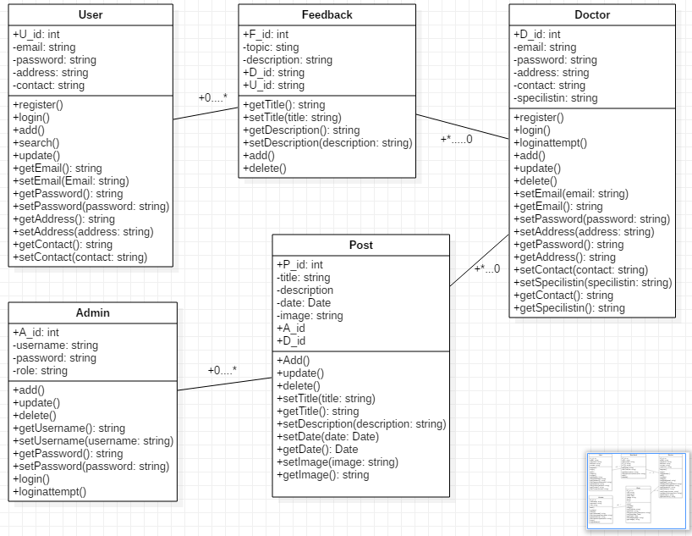

### 2.2.2 Dynamic modeling

Dynamic modeling identifies the behavior of the system over time and flow of control and events. Event trace diagram and state transition Diagram represent the dynamic model.

Event trace diagram for login to the system is mention below:

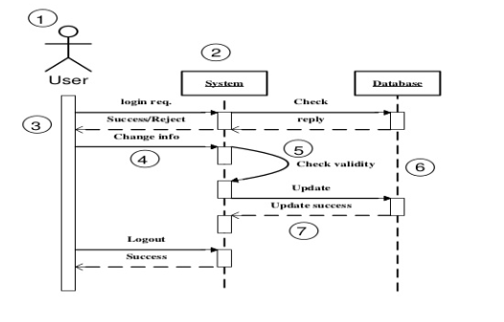

### 2.2.3 Functional modeling

Functional models are the sets of DFDs (Data flow diagrams) that identifies the internal processes are independently from how these processes are performed. Initial DFD of the doctor information system

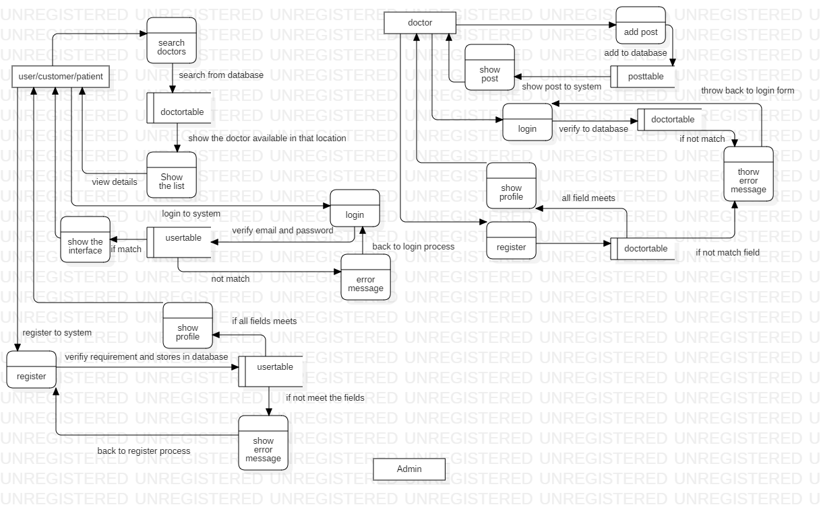

## 2.3 Feasibility study

Feasibility study is analysis process in which all the factors like economic, technical, legal, ethical and scheduling of the project is studied to find out whether the project is feasible to procced. If the strength of project overcomes the weakness of the project and if opportunities overcome the threat of the system then the project is feasible to do.

1. **Economic feasibility:**

Economic feasibility deals with the cost/ benefits analysis of the system/ project. It will check whether the project budget is sufficient for the cost of development of this project. If it is sufficient enough then the project is proceeded. If not then the project will compromise some function/ features or even drop. While seeing the **Doctor information system,** total cost of the development is sufficient enough for the budget.

1. **Technical feasibility:**

Technical feasibility study focuses on the technical aspects like technical resources used, tools used for the development. I have used XAMPP, Nodejs, git bash, sublime text editor etc. while developing the project which are hardware compatible and did not need more space/ memory for installation. All this tool used are free of cost and hardware compatible so, I think this project is technically feasible.

1. **Ethical feasibility:**

Ethical feasibility deals with all the social, cultural, environmental, ethical aspects of the project. This is not developed for the specific religion so anyone can use it. Even I am not going to use specific cultural picture/ images or any other stuff. And it cannot create any social conflict. So, I think it will be socially, culturally, and ethically feasible to do.

1. **Legal feasibility:**

Every tool used are legally available for free. So, it will not cause any legal issue in coming future. Doctor information system which I’m going to create will follow the law of country for the development of product. Therefore, it will not cause problem while developing the product. So, I think the system will be legally feasible.

1. **Schedule feasibility:**

It deals with the timing feasibility of the project like does the project end in time? Does it include all the features/ functionality in time period provided for each functionality? This project will not have bulky and complex functionality. It has 2/3 days extra for the parts of development so, I think there will not problem in time management. So, this project is time wise feasible to do.

## 2.4 Information gathering:

It is the process of gathering requirement and information of the user interface with the help of different methodology like interview, survey, questionnaires, observations, study of the existing documents, etc. Information gather will properly documented, well defined and should be taken to the appropriate group. So, that it can possess some quality information for the well development of the system. For the information gathering I have used Documentation and questionnaire.

### 2.4.1 Questionnaire/ survey

It is the process of gathering information to the large number of people with the help of some sorts of sample questions. Question sample is given below:

**Questions:**

1. Name:
2. Age: [ ] below 20 [ ] between 20-40 [ ]between 41 -60 [ ] 60 above
3. Religion:
4. Education level:
5. Address:
6. Occupations:
7. How often you use internet?

[ ] once a week [ ] daily [ ] once a month [ ] on the basis of need

1. How often you visit health related websites?

[ ] once a week [ ] daily [ ] once a month [ ] on the basis of need

1. How often you provide some queries or comment on health-related post?

[ ] sometime [ ] never [ ] on the basis of need

1. Did you like see diseases related newsfeed/ post?

[ ] yes [ ] no

1. How often you visit to doctors for the regular checkup?

[ ] Regular [ ] when fell sick

1. What types of interface did you like to have in such web applications?
2. Did you provide feedback to the doctor’s services after the consultant/ checkup?

[ ] Yes [ ] No

1. Did you like to online consult with doctors?

[ ] Yes [ ] No

1. Which type of color should be in the background of such web base application?

…………………………………………………………………………………………..

1. Any feedback that you like to provide

…………………………………………………………………………………………….

Thank you!

**Reason for using questionnaire:**

🡪 the system going to develop is for large number of people so, it will not be appropriate to use interview with people.

🡪 save time and efforts

🡪 reliable

### 2.4.2 Documentation

I have visited a lot of website for the research of functionality that should be included in Doctor information system.

## 2.5 Software requirement specification

In the software requirement specification, I have used some method to prioritize and identifies the requirement gather for the doctor information system. The method that are used are given below:

1. **Functional requirement:**

Functional requirements are those requirements which must be included in the web application. We must call that requirements are the foundation of the system. These describes systems behaviors. Some of them are given in the table:

|  |  |  |  |  |
| --- | --- | --- | --- | --- |
| F-ID | Title | Dependency | Rational | Description |
| F001 | Registration | No | Security | Provide email, password and other information. |
| F002 | Login | Yes [registration] | Security | Provides email and password |
| F003 | Show profile | Yes [F001] | Availability | Show provide information during registration |
| F004 | Search doctors by choosing locations | Yes [F001] | Availability | It is dependent on the information provided by the doctors while registration |
| F005 | Update doctors’ profile | Yes [F001] | Increase reliability and accuracy | It is dependent upon doctor id for the changes. |
| F006 | Delete information by admin | No | Increase reliability | If some doctor is fraud then their profile should be deleted |
| F007 | Doctor can add post | No | Increase interaction to system | Doctor can add some health-related post so that improve the knowledge of others users. |
| F008 | User can update their profile | Yes [F001] | Reliability | It increases interaction of the users to the system |
| F009 | User can provide feedback | No | Involvement | They can provide feed on what they like? what they hate of the system? what should be improve? |
| F010 | Doctor can edit the post | No | reliability | The doctor who had add the post must be able to edit the post |
| F011 | Admin can edit the post | No | Availability | Admin can able to edit the post |
| F012 | Admin can delete the post | No | Availability | Admin can be able delete the post |
| F013 | Doctor can provide feedback | No | Involvement | Doctor can able to provide feedback |
| F013 | View users available | No | Availability | Admin can be able to see all the users available to the system |
| F014 | View post details | No | Availability | Admin should be able to see the numbers of post that had been added |
| F015 | Login attempt | F002 | Security | Admin and doctor cannot login with incorrect username and password. If they try more than 3 time then they would be block for 3 minutes for the next attempt. |

1. **Nonfunctional requirements:**

Those requirement without which application should be just working but not well. These all the function make more decorative and make our product sustain in the market. Some of them are mention below in the table:

|  |  |  |  |  |
| --- | --- | --- | --- | --- |
| NF-ID | Title | Dependency | Rational | Description |
| NF001 | Making system secure | Non | Provide security | It helps to increase the level trust |
| NF002 | Available when require | Non | Increase reliability | It makes system reliable |
| NF003 | Scalable | Non | Increase the productivity |  |
| NF004 | Maintainable | Non | Sustainability of the system |  |
| NF005 | Usability | Non | Make more usable to the users |  |
| NF006 | Efficiency | Non | Use less resource and search faster |  |
| NF007 | Online consulting | Non | Availability | User can online consult to doctor |
| NF008 | Online payment | Non | Security | User should be able to pay securely by use of card |
| NF009 | Buy online consulting membership for period of time | Non | Availability | User can able to buy membership for the certain period of time |
| NF010 | Able to search hospital | Non | Availability | In future it will include hospital fields too |
| NF011 | Able to get blood bank information | Non | Availability | In future it may include function like where the blood banks located and even able to get if blood available if needed |
| NF012 | Provide rating to the doctors | Non | Interaction | User can able to provide rating to the doctors. |
| NF013 | Set roles | Non | Efficiency | Admin can able to create new admin and set the role and provide authorization level. |

1. **MoSCoW prioritize:**

MoSCoW function is invented by “Dai Clegg” from the software company Oracle. MoSCoW prioritize is about setting the requirements by the order of priority. To deliver right working product at right time so, that client can use the working software. It makes easier and clearer. What function should be done first?

Every capital letter of MoSCoW has its own meaning. Full form of the MoSCoW is given below:

* Must have: those requirements which should give more priority during development. These all are implemented first and help to make working and without its software will be useless.
* Should have: these are less important than “Must have” function but these should be later after completing must have functions. These are like supports of the foundation of the product.
* Could have: It should be done if we have enough time if not then it will be implemented in the next version.
* Won’t have: these features should not be included in the system.

MoSCoW prioritize table is mention below:

|  |  |  |  |
| --- | --- | --- | --- |
| M-ID | Title | MoSCoW | Rational |
| M001 | Register | Must have | Security |
| M002 | Login | Must have | Security |
| M003 | Show error message | Should have | Informative |
| M004 | Login attempt | Should have | Security |
| M005 | Show doctors list | Must have | Availability |
| M006 | Admin can another admin and provide authority | Could have | Increase efficiency |
| M007 | User’s provide feedback to doctors | Could have | User interaction |
| M008 | Doctor can post health related news | Should have | Informative |
| M009 | User provide rating to the doctors that they have consulted | Could have | Increase interaction |
| M010 | Doctor can reply the message post by users | Could have | User satisfaction |
| M011 | User can buy premium consulting membership | Could have | Increase efficiency |
| M012 | Reliable | Should have | Increase satisfactions |
| M013 | Security | Should have | Increase privacy |
| M014 | Available | Should have | Increase user participations |
| M015 | Scalable | Should have | Increase productivity and efficiency |
| M016 | User update their profile | Should have | Increase user interaction |
| M017 | Doctor update profile information | Should have | Increase doctor interaction |
| M018 | Admin delete the doctor information if not available | Should have | Reliability |
| M019 | User comment to the doctor post | Could have | Feedback |
| M020 | Search by hospital | Could have | Select category |
| M021 | Search by selecting doctor specialist | Could have | Increase efficiency |
| M022 | Show the users past consulting history | Could have | Reliability |
| M023 | Online consulting | Could have | Interaction |

## 2.6 Use case diagram

Use case diagram show the user interaction to the system. There are some internal and external factor for making the interaction to the system. These external agents are known as the actors.

Purpose of using Use Case Diagram are mention below:

* It is used to gather the requirement of Doctor information system.
* It is used to show outside view of the system.
* It shows the interaction of actors to the functionality
* It helps to determine actor which is going to influence the system

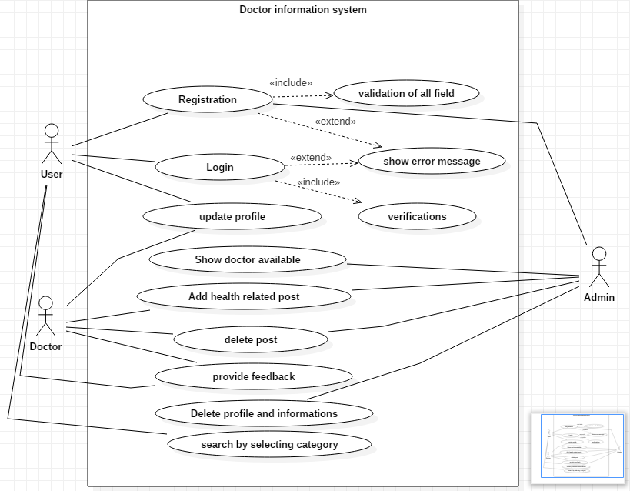

## 2.6 System Architecture

### 2.6.1 Design pattern

I will like to use MVC (Model View Controller) design pattern for this project.**Invalid source specified.** In MVC design pattern whole project will be divided in three main logical component Model, View and Controller. Model component is related to all the data-related to logic that user works with. View component is related to all the UI logic. Controller works intermediate between model and view. It handles the user request by processing data logic (model) and interact with view.

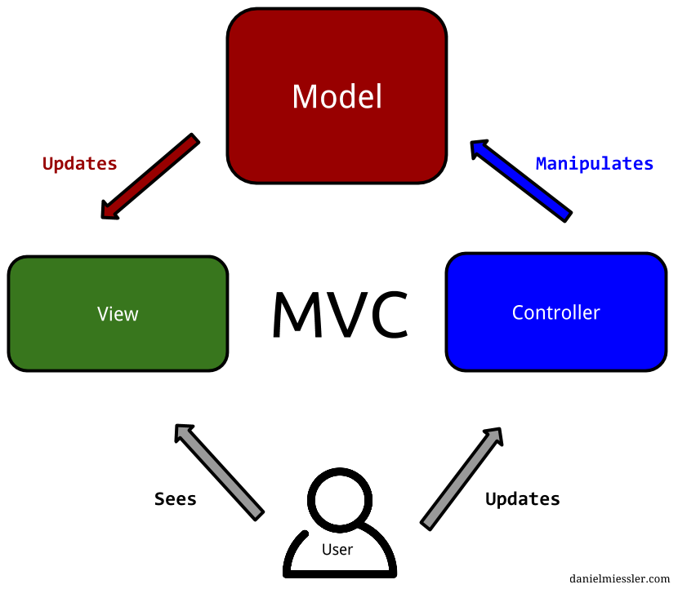

I will be using this design pattern because of these reasons which are given below;

* It decreases the complexity of program.
* It increases the maintainability of the program.
* We can easily find out where is the problem while something went wrong.

### 2.6.2 System architecture definition

System architecture is the conceptual model that determines behavior, structure of the system. For the system architecture I will like to use **3-tier** architecture because a tier can be changed or relocate without affecting other tier and makes easier to continually evolve the application as new need or requirement and opportunities arises. 3-tier architecture is modular client server architecture that consists of a presentation tier, data tire, application tier.**Invalid source specified.**

* **Presentation tier:** this tier is built with HTML5, CSS and JavaScript are deployed to computing device with web browser. It communicates with other tiers with the help of API (Application Program Interface) call.
* **Data tier:** Data tier is referred as storage tier. It consists of database and program for performing data read and write operation.
* **Application tier:** it is also known as logical tier which is written in programming language such C#, java and contains business logic that can hold up application’s core function.

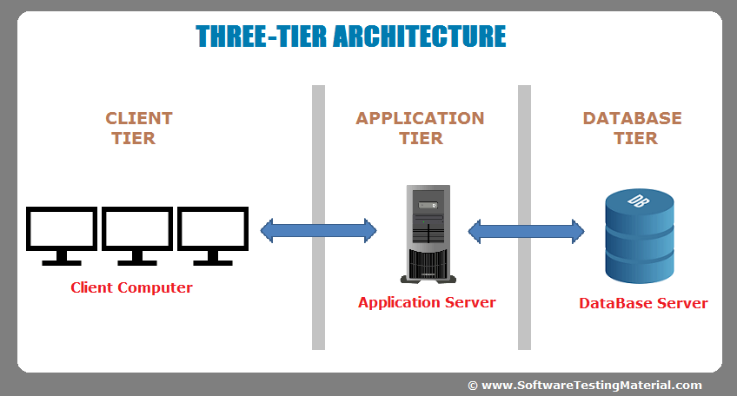

### 2.6.3 Scenario

“The Brothers” Company is a software company established in 2010, located at Westgate Court, Westgate St, Cardiff CF10 1DD, UK. This company is hire you to provide working web application which should have some features.

For users:

* User can be able to login to the system
* User can be able to register to the system
* User can be able to provide feedback
* User can be able to search the doctor located in his community by selecting the location
* User can be able to update his information

For doctors:

* Can be able to register to the system
* Able to add the post
* Able to delete the post
* Able to update the post
* Able login to system
* Login attempt will not more than 3 times
* Update profile information

System:

* Admin login
* Login attempt will not be more than 3 times
* View the list of doctors
* View the post
* Add the post
* Update the post
* Delete the post
* Delete the doctor information/ account if not valid
* Show the users details

#### 2.6.3.1 NLA (Natural Language Analysis)

It is the process of identifying verbs, nouns and adjectives from the given scenario or descriptive text.

* Nouns are related with possible candidate class
* Verbs are related to possible candidate methods
* Adjectives are related to attributes

**Candidate method selection:**

Candidate methods are those methods which should be include to the system for the development of the system.

**Verbs:**

Add, delete, login, register, provide, select, located, established, hire, attempt, show, View, search

Candidate method selection are listed below:

|  |  |  |  |
| --- | --- | --- | --- |
| V-ID | Verb | Candidate method | Description |
| V001 | Add | Yes | It helps to create the post which will be more useful to the system to implement |
| V002 | Delete | Yes | It will used to delete not useful information and post |
| V003 | Update | Yes | It is used to update information by the all the users, doctors, admin |
| V004 | Login | Yes | It is one of the most useful function of any system to add the security level |
| V005 | Register | Yes | It is another useful function |
| V006 | Provide | No | It is not specific |
| V007 | Select | No | It is out of scope |
| V008 | Located | No | It is out of scope or need not to mention |
| V009 | Established | No | It is out of scope or not useable function throughout the project |
| V010 | Hire | No | Out of scope |
| V011 | Show | No | Similar to view |
| V012 | Attempt | Yes | It will increase the security level |
| V013 | View | Yes | It will show the information like if user want to view his/her profile, doctor list, post |
| V012 | Search | Yes | It shows search list |

Candidate method are given below:

|  |  |
| --- | --- |
| S. N | Candidate method |
| 1 | Add |
| 2 | Delete |
| 3 | Update |
| 4 | Login |
| 5 | Register |
| 6 | Search |
| 7 | Attempt |
| 8 | View |

**Candidate class selection:**

Those classes which are fundamental of this system are known as candidate classes.

**Nouns lists:**

Company, software, web application, users, system, user, post, doctor, community, feedback, information, admin

Candidate class selection are given below in the table:

|  |  |  |  |
| --- | --- | --- | --- |
| C-ID | Noun | Candidate class | Descriptions |
| C001 | Company | No | It is out of scope |
| C002 | Software | No | It is not related to the system and it is out of scope. |
| C003 | Web application | No | It is not required for the class |
| C004 | Users | No | It is better to use singular form |
| C005 | System | No | It does not provide specific meaning |
| C006 | User | Yes | It will be appropriate to user as customers of web-based application |
| C007 | Post | Yes | It will contain information of who posted and health related information. |
| C008 | Doctor | Yes | It is type of user but have different role it is better to use it as different class. |
| C009 | Community | No | It does not have specific meaning |
| C010 | Feedback | Yes | For the better normalization it useful to make feedback as class. |
| C011 | Information | No | No specific meaning and cannot be able use as class |
| C012 | Admin | Yes | It should be added as class because its main functionality to handle the system. |

Candidate classes are given below:

|  |  |
| --- | --- |
| S. N | Candidate class |
| 1 | User |
| 2 | Post |
| 3 | Doctor |
| 4 | Feedback |
| 5 | Admin |

Initial class diagram is given below:



# Chapter 3 Design

Design is the process of designing all the elements of system architecture, modules and component of the system. All the requirements specification collected from the analysis phase is studied in this phase and then design on the basic of requirement. It helps to determine architecture of the system.

In the design phase, it includes four modelling:

* Structural modeling
* Behavioral modeling
* Database modeling
* UI (user interface) modeling

## 3.1 Structural modeling

Structural modeling is static view of system which helps to emphasizes the structure of the objects and their classifiers, attributes, relationships and operations.

### 3.1.1 Final class diagram

#### 3.1.1.1 Definition of class diagram

Class diagram is static diagram that represent static view of the system, and visualized the relationship between the classes and objects. It is a structural diagram which shows a collection of classes, objects, attributes, associations, interfaces, collaborations and constraints.

#### 3.1.1.2 Justification for using class diagram

* Provides static view of the application
* Describes the responsibility of application
* Shows the relationship of classes
* Provides flexibility in object-oriented modeling/ structure

#### 3.1.1.3 Notation used in class diagram

|  |  |  |
| --- | --- | --- |
| Symbols | Meaning | Descriptions |
| + | Public | Able to access from outside |
| - | Private | Access modifier which can be accessible only within class |
| # | Protected | Access modifier which can be accessible within and child class |
|  | Aggregation | Show the special relationship of classes with another which specifies whole-part relationship between the aggregated(whole) and component part |
|  | Composition | Connect contained classes. |
|  | Association | It shows simplest type of relationships. |
|  | Generalization | Shows inheritance which specifies child classes inherit the parents class attributes. |
|  | Dependency | Shows one class is dependent to another. |
| * | Many | Specifies many, generally used to show relationship with other class |

#### 3.1.1.4 Actual Class Diagram

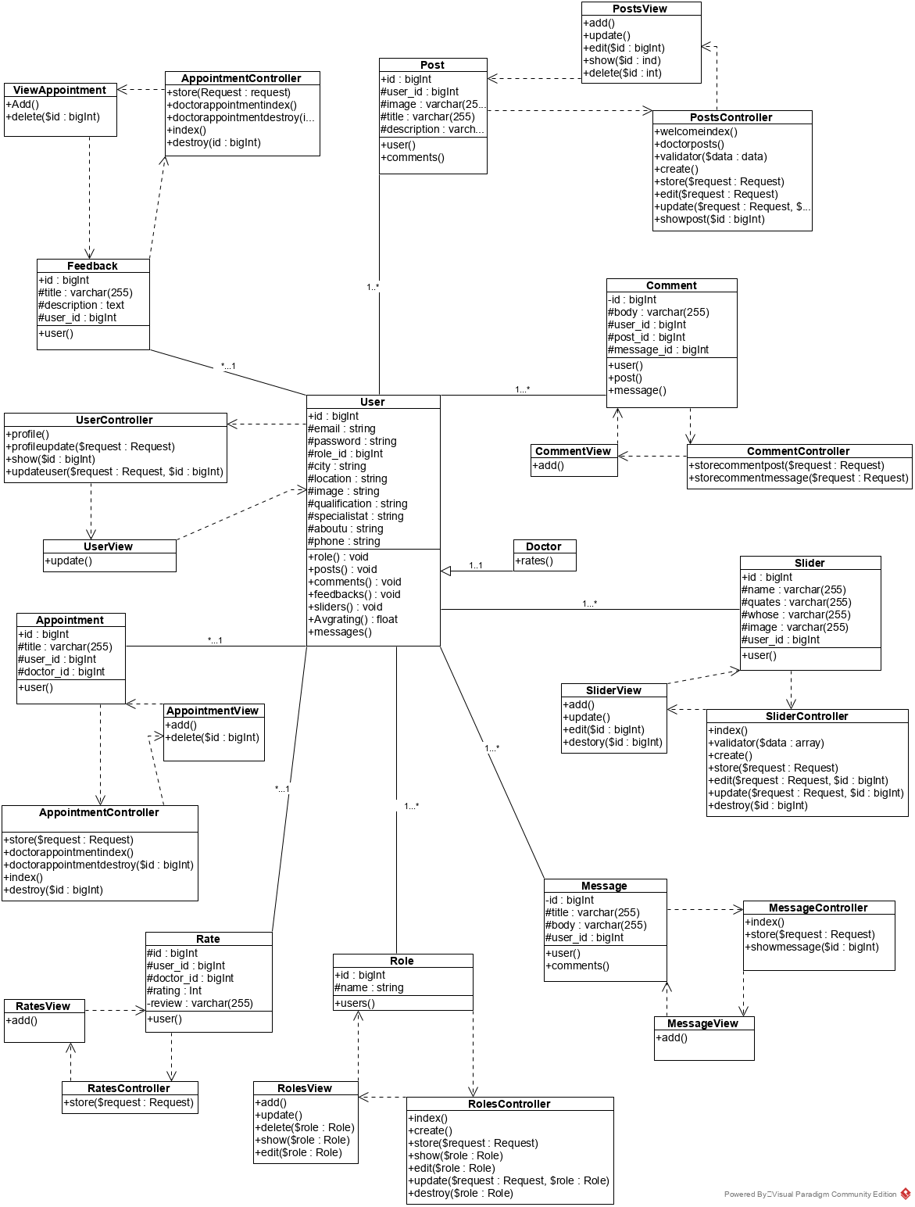

#### 3.1.1.5 Explanation of Class Diagram used

Here I have make main classes named: roles, comments, users, feedbacks, posts. There are actually 3 roles in the system Admin, doctor, normal user. According to the role, different user has different authority.

Class user consist of different attributes like email, password, role-id, city, location, specialist-in, etc. it has functionality like register, delete user, update profile, search.

Class roles consist of two attributes name and id.

Class comments consist of four attributes are id, user-id, body and comment-able-type. With functions Add-comment, update-comment and delete-comment.

Class feedback has attributes id, topic, description and user-id with functionality like add, delete, and view feedback.

Class posts consists of id, title, description, user-id attributes and add, update, delete post functionality.

### 3.1.2 Flow chart

Flow chart is a visualization of the workflow or process or representation of an algorithm, step by step approach for solving the task. It traces the information and work through it, and even highlight the process and decision making of system. So, it shows overall structure of system process.

#### 3.1.2.1 Justification for Flowchart diagram

* Helps to identify different element of the process
* Helps to understand various interrelationship among steps
* Helps to gather data and information of the process
* Helps to improve the process

#### 3.1.2.2 Symbols and notations used while drawing the flow diagram

|  |  |  |
| --- | --- | --- |
| Notations | Meaning | Description |
|  | Flowline | It shows the direction of the process flow |
|  | Terminal | It shows start and end point of the process. |
|  | Process | Rectangle in shape represent the set of operations or process that changes the value, form |
|  | Decision | used in position of conditional statement like true or false, yes or no, it is diamond in shape |
|  | Input/ Output | Represent as parallelogram, used to display input and output data process |
|  | On page connector | Represent as small circle which has letter inside, shows the matching jumping point. |
|  | Off-page connector | Represent as pentagon, used for when the connector is another page |
|  | Pre-define process | Represented as rectangle which has also two vertical line inside, it is marked up process or set of process that are defined elsewhere |
|  | Single document | Represented by rectangle with wavy base, process step for producing the document |
|  | Multi-document | Represented as multiple rectangle with wavy bases which are stacked, process step for producing the multiple document |
|  | Data-store | Used for any process that stores data |
|  | Datafile/ database | Represented as cylinder |
|  | Manual operation | Represented as trapezoid shape, operation to process which can only be manual |
|  | Preparation or Initialization | Represented as elongated hexagon, used for the setting a route |
|  | Summing junction | Represented as circle with cross inside, shows when multiple branches converge into single process |
|  | Collate | Represents a process step which requires managing data, information or materials accordingly in standard format |
|  | Manual input | Keyboard like quadrilateral top irregularly slopping up from left to right corner, shows the process where the operator is promoted for the information that must be manually inputted |
|  | Sort | Represented as two triangle whose base are merge top corner seems opposite to each other, used to show the shorting of data, information, materials |
|  | Annotation | Represented as open rectangle with a solid or dash line connecting to it, indicating additional information about a step in the system |

#### 3.1.2.3 Flowchart diagram

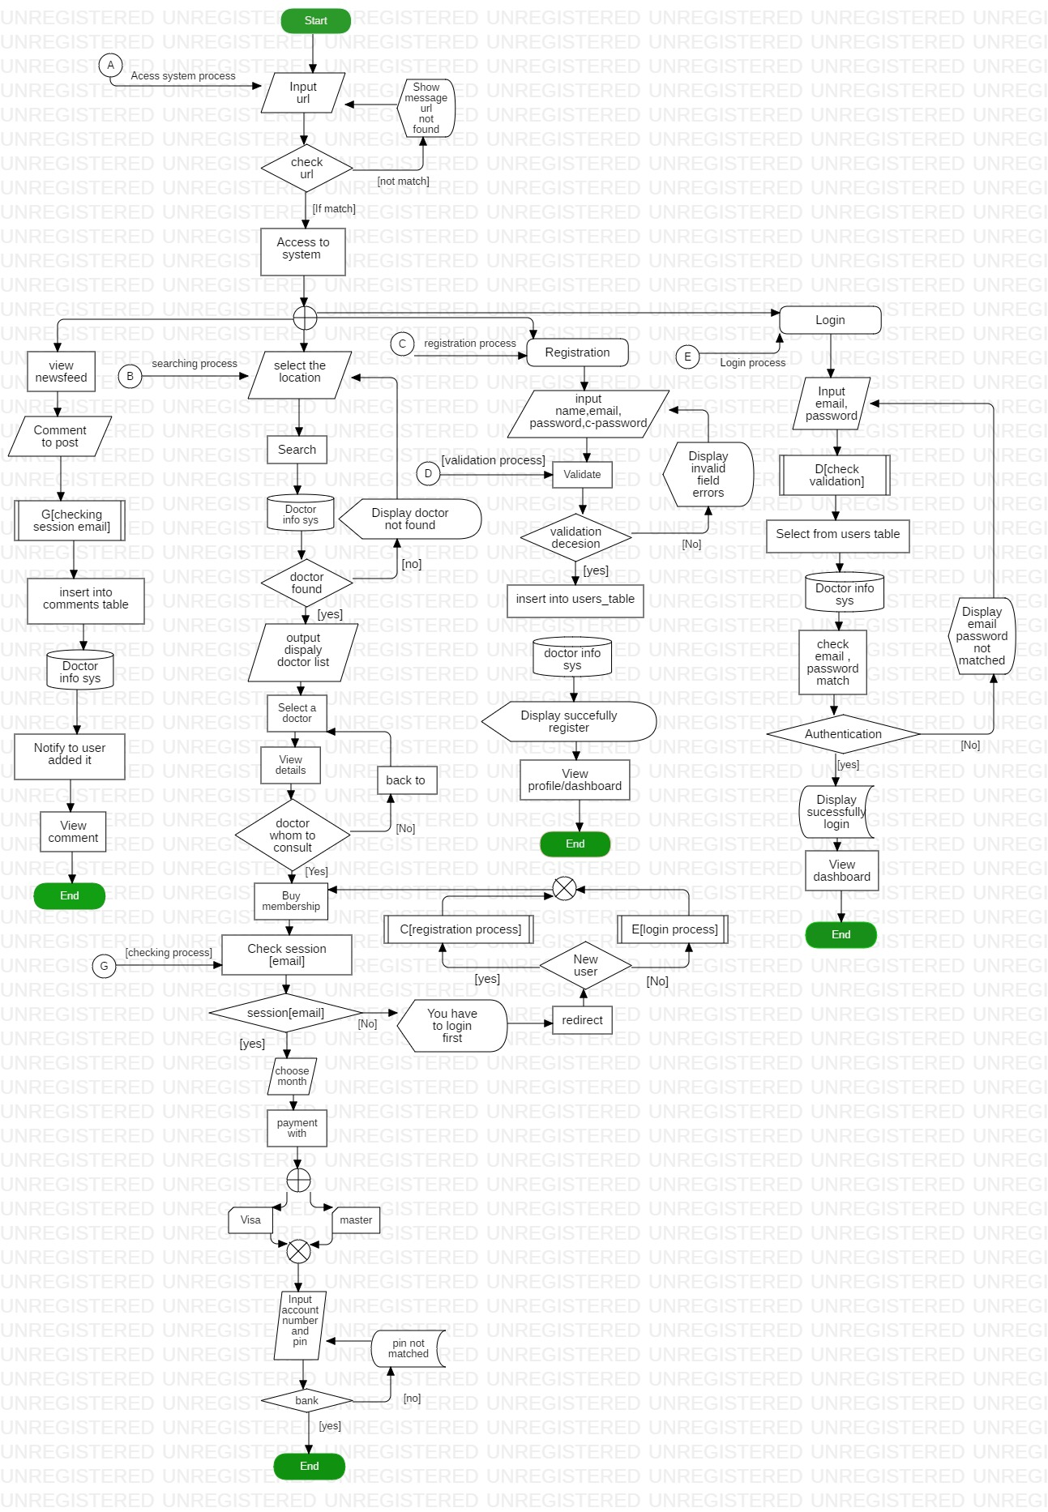

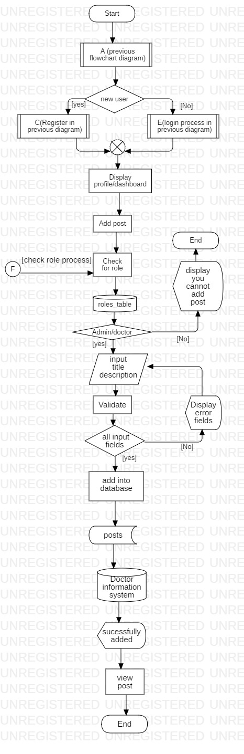

#### 3.1.2.4 Explanation of the flowchart diagram

Here in those two diagrams is shows how the user input data how it converts into output? how the data changes with the process? what are the activity perform by the users? It shows how the system validate the given input of user and if not matched then send back to login form showing the field does not match requirement error message, if matched send to database to check whether the user exit, if exit redirect dashboard showing message successfully login and if not exit send back to login form displaying error email , password does not matched . Similarly, while creating the new user we can send input and system validate similar as login then send to database to check whether user having same email exit or not if exit send back to register page and display error email address already exit. If not exit then register new user and send to dashboard and display you are successful to register to system.

## 3.2 Behavioral modeling

It describes the dynamic nature of the system. It is used to model interaction between objects. Activity diagram and sequence diagram are the example of the behavioral modeling. It is time dependent. It shows run time activity process.

### 3.2.1 Activity Diagram

Activity diagram is the behavioral modeling diagram which represent dynamic view of the system and describes how the activity are coordinated. It represents the workflow of system.

#### 3.2.1.1 Justification for the use of Activity Diagram

* Used to visualized the activity flow of the system
* Used to describe the sequences from one activity to another
* Shows the parallel, concurrent and branched flow of the system

#### 3.2.1.2 Symbol or notation used in Activity diagram

|  |  |  |
| --- | --- | --- |
| Symbol | Name | Description |
|  | Start | Represent the beginning of a process or workflow in an activity diagram, represented as a dark circle |
|  | End | Represent the completion/ end of the process, represented by a circle containing a dark circle in middle |
|  | Activity/ process | Main component, indicates the activities that make up a modeled process |
|  | The Connector | Represented by arrow line, shows the control flow or directional flow of the activity |
|  | Join or Synchronization bar | Represented by thick horizontal line or vertical line, combines two concurrent activities and re-introduce them to flow where only one activity occurs at a time |
|  | The decision | Represented by diamond shape, represent the branching of various flow with a symbol acting as frame or container |
|  | The Fork | Symbolized with multiple arrowed line from join, splits a single activity flow into two concurrent activities |
|  | Note | Allows the diagram creator to communicate additional message that do not fit within the diagram itself |
|  | Send signal | Means that a signal is being sent to a receive activity |
|  | Receive signal | Demonstrate the acceptance of an event after event is received |
|  | The flow final | Shows the ending point of a process flow |
|  | Option Loop | Allows to model a repetitive sequence |
| **H** | Shallow history pseudo-state | Represents a transition that invokes the last active state |
|  | Swimlane | Can be horizontal or vertical, represent the activity objects |
|  | Merge | Represent by diamond shape having an arrow ahead, two or more non concurrent |

#### 3.2.1.3 Activity Diagrams

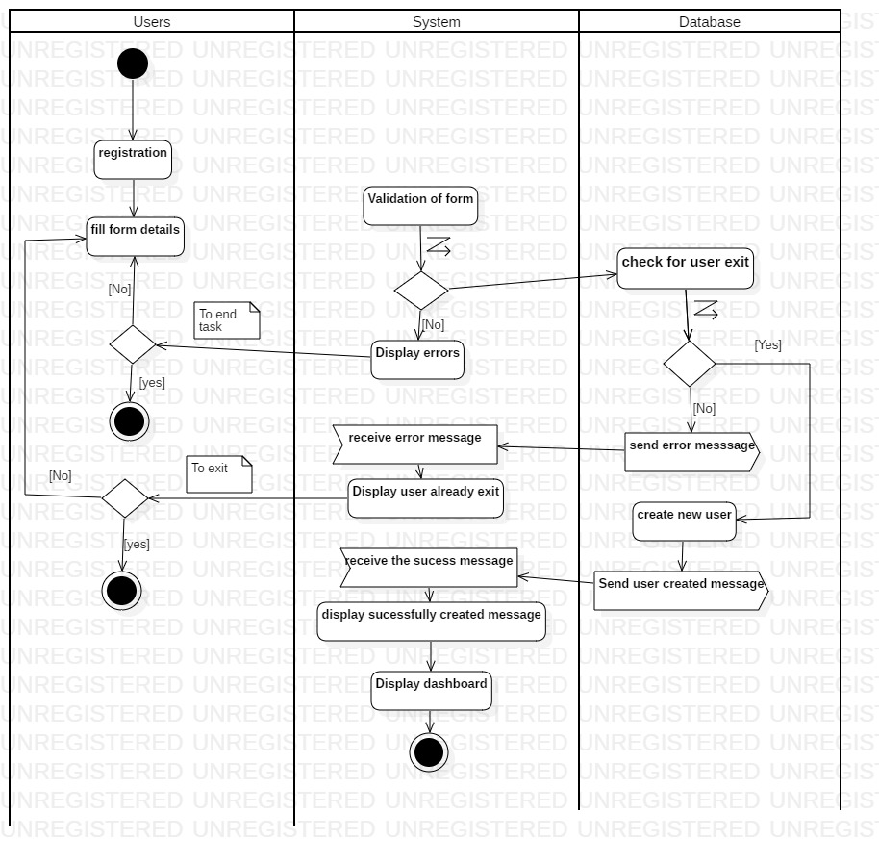

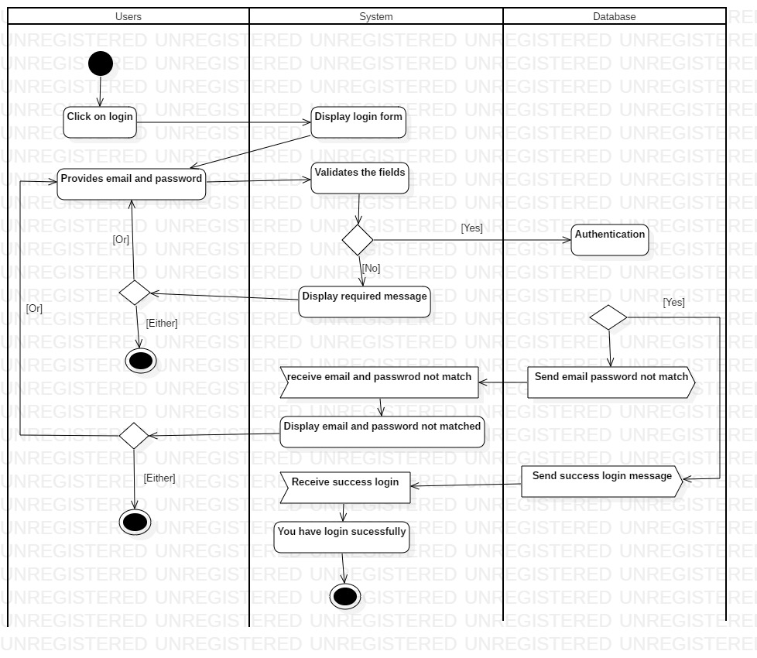

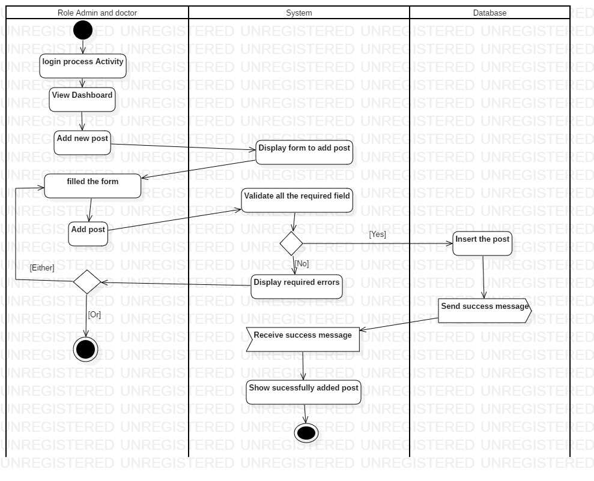

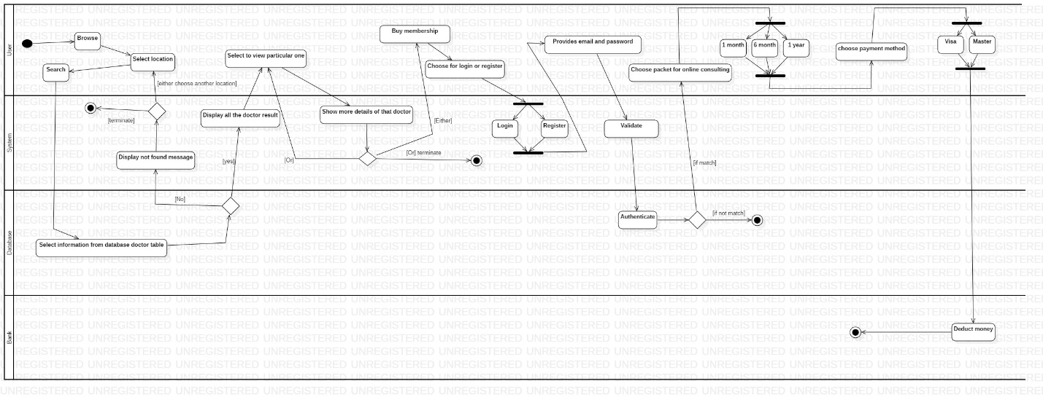

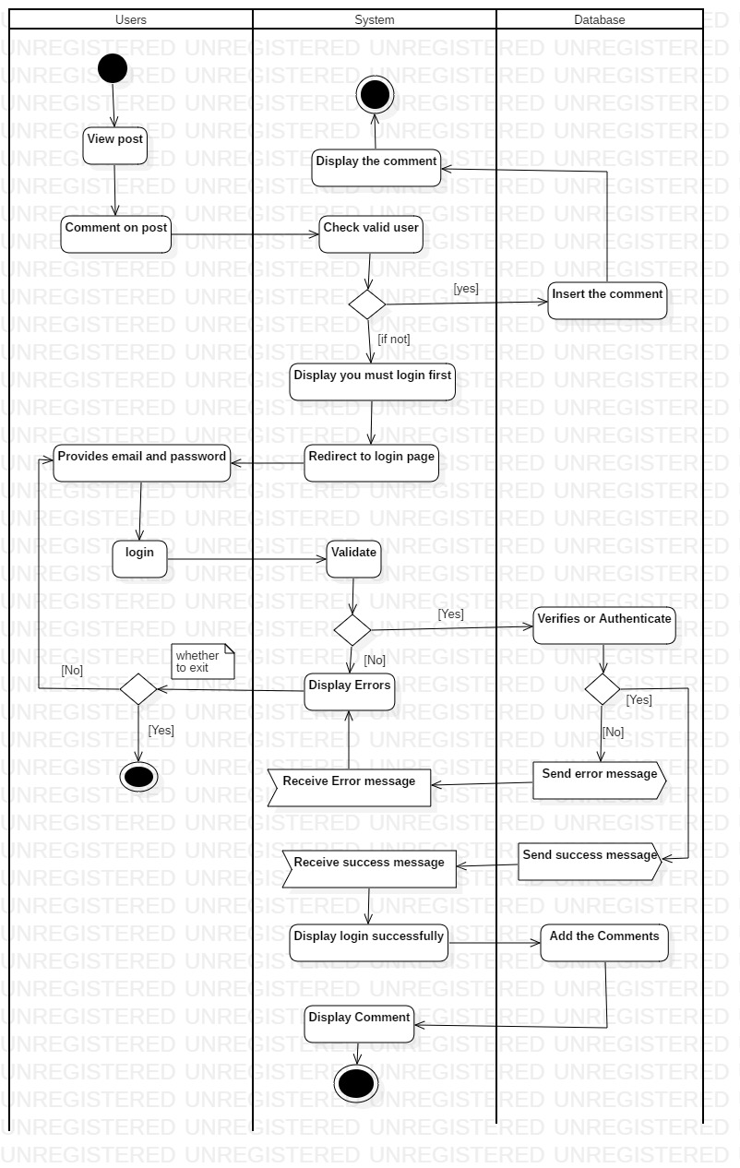

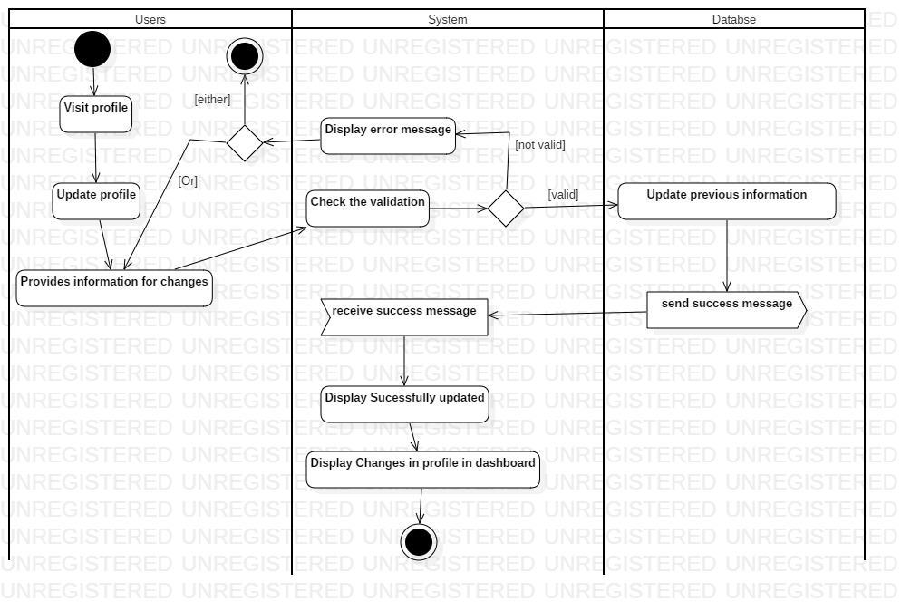

#### 3.2.1.4 Explanation of diagram

Here it shows the interaction of functionality with the user activity.

### 3.2.2 Sequence Diagram

It is the behavioral diagram which shows how the processes operate with one another and in what order. It represents the object interaction arranged in time sequence. It is just like the event trace diagram. It describes the flow of the messages, actions or process between objects.

#### 3.2.2.1 Justification for using Sequence Diagram

* Shows the logical flow of the system
* Shows the set of events and objects interaction
* While implementing the codes it makes lot easier to understand and implement the logic
* Makes other person to understand the system event interaction with objects and even the actors

#### 3.2.2.2 Symbol used in Sequence diagram

|  |  |  |
| --- | --- | --- |
| Symbol | Title | Description |
|  | Object | Represented as rectangular box at top with object name inside and followed by vertical line or dotted line, represent the different objects interact with each other |
|  | Actor | Represent the external user interact with system |
|  | Boundary | Indicates system boundary |
|  | Entity | Represents the system data |
|  | Control | Serves as intermediate between boundaries and entities, schedules and manage interaction between them |
|  | Activation bars | It is like box placed at lifeline, indicate an object is active |
|  | Synchronous | Dark arrow head like structure, used to send the message |
| **<**- - - - - - - - - - - - - | Receive message | Used to reply message |
| < | Asynchronous | Used to send the message, does not wait for receiver to process the message |
| Loop | Loop | Used when there looping condition |
| Alt | Alternative | Used when event have some condition alternative to first one |
| opt | Optional | Used when the event process has optional statement to choose either one of them |
|  | Comment or note | Used to comment the notes |

#### 3.2.2.3 Actual Sequence diagrams

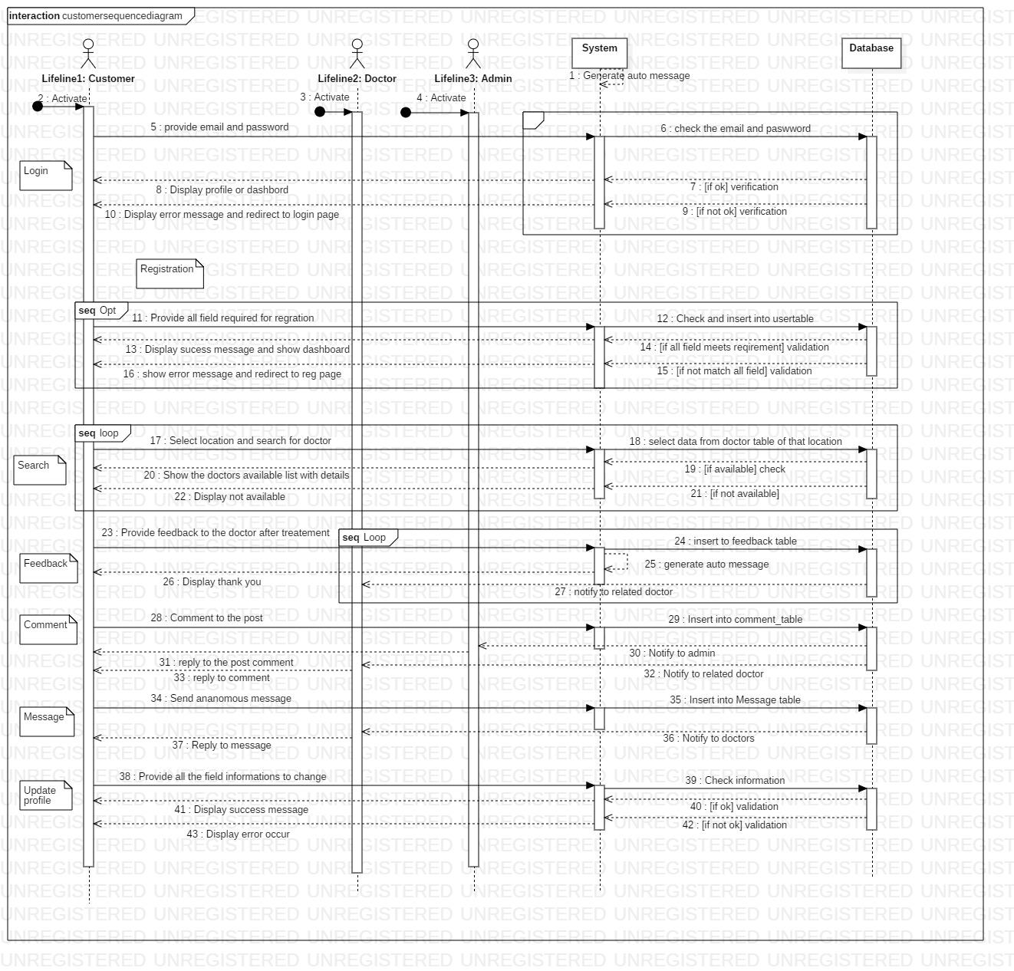

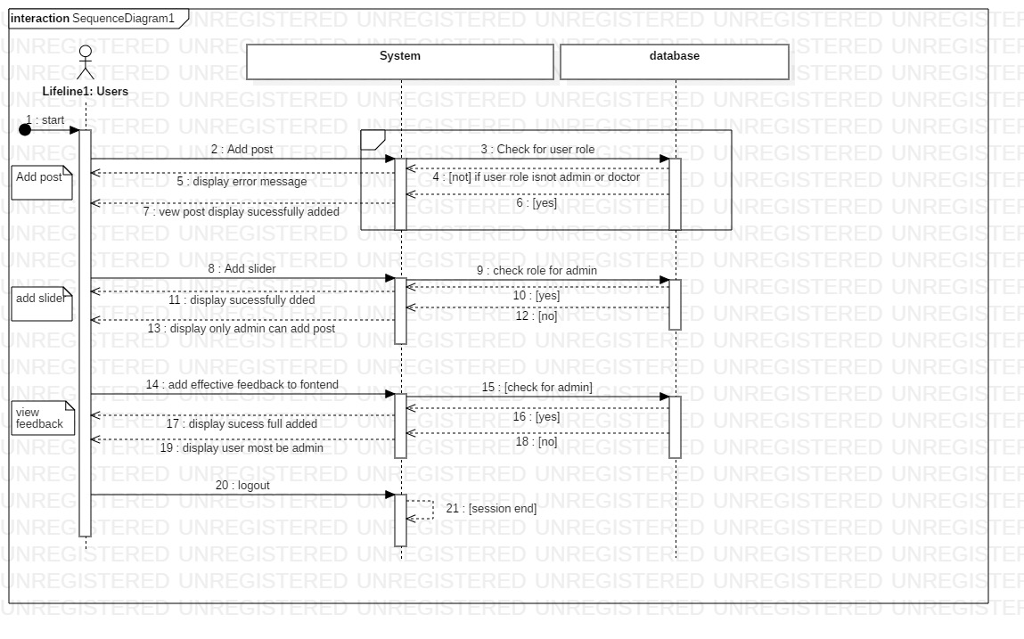

#### 3.2.2.4 Explanation of Sequence diagram used

Users: role -normal user/ customer can able to search, comment to post and reply to comment, login, register, update profile, provide feedback

Users: role -doctor can able to add the new post, update their post, update their profile, reply to message, reply to post comment, login, register

Users: role -admin Can able to view users list able delete them, login, add post, update post, add sliders, update slider, delete sliders, delete post, reply to comment, maintain to view the best review

## 3.3 Database modeling

It deals with database design and modeling.

### 3.3.1 Data Dictionary

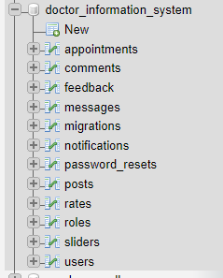

Appointments table

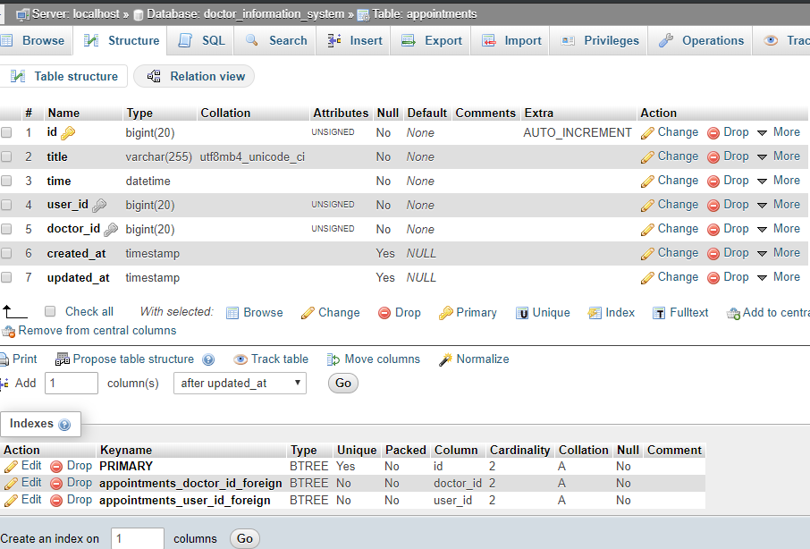

Comments table

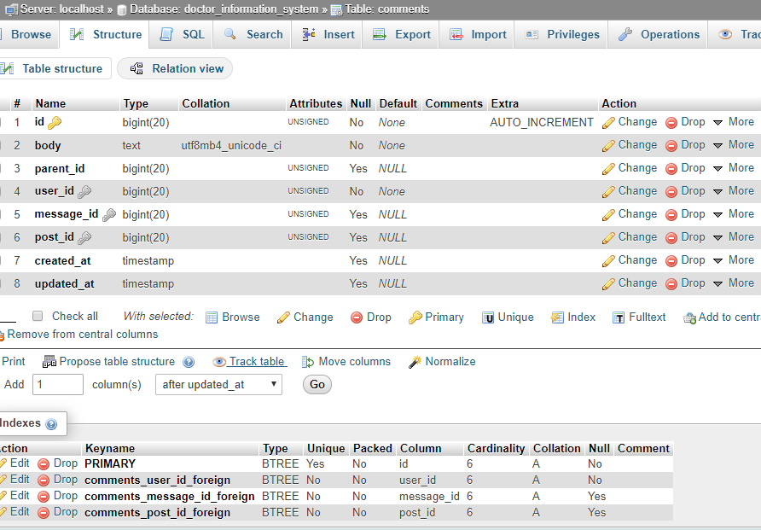

Feedbacks table

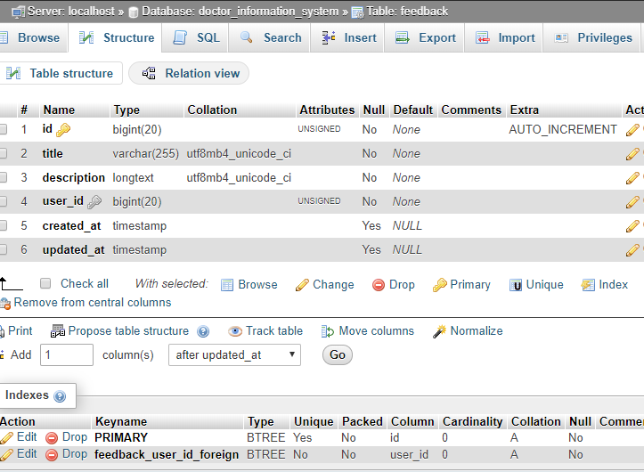

Messages table

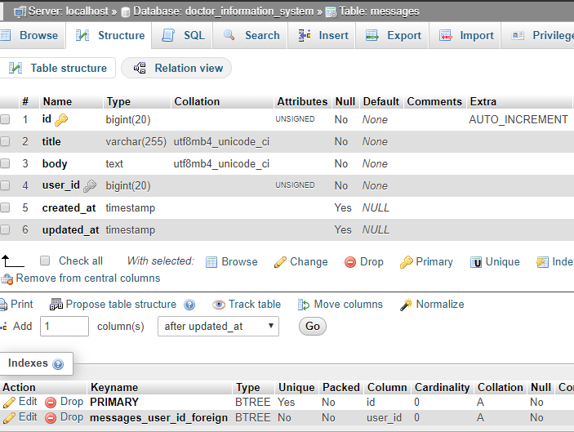

Migrations table

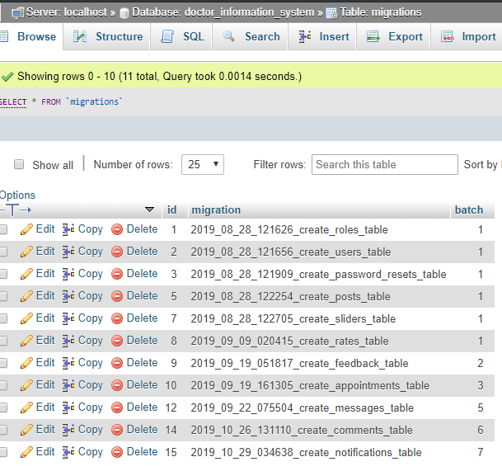

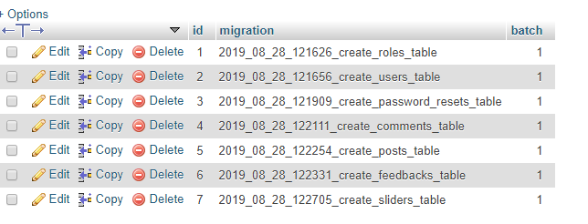

Notifications table

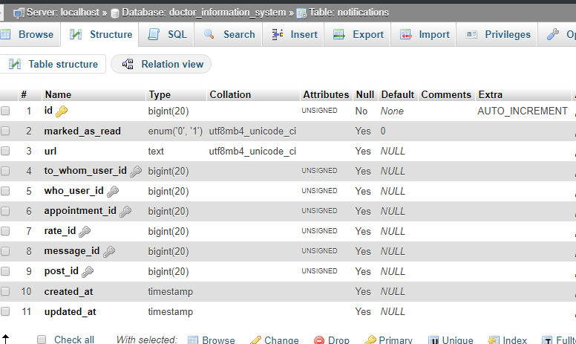

password_resets table

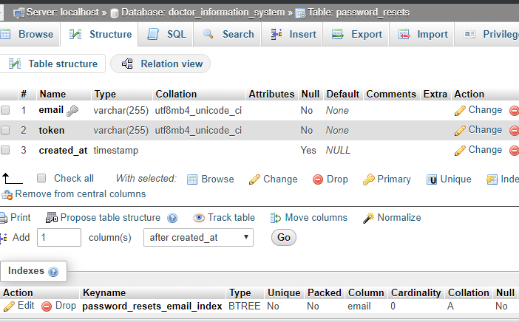

posts table

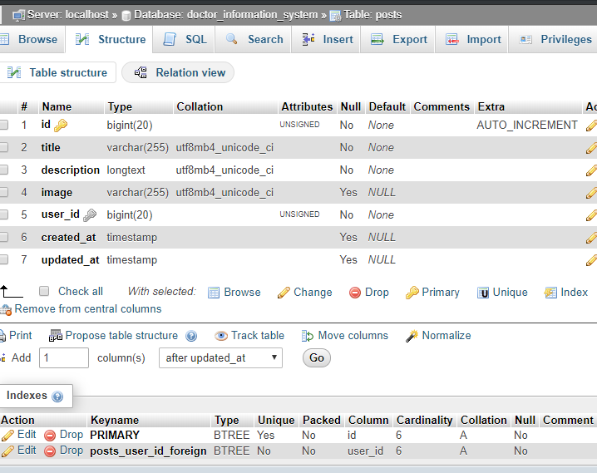

Rates table

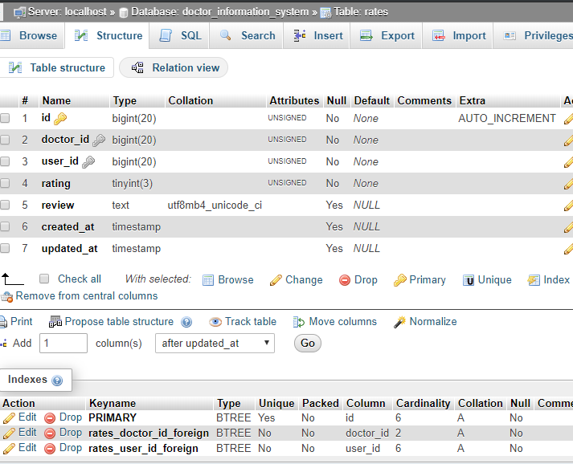

roles table

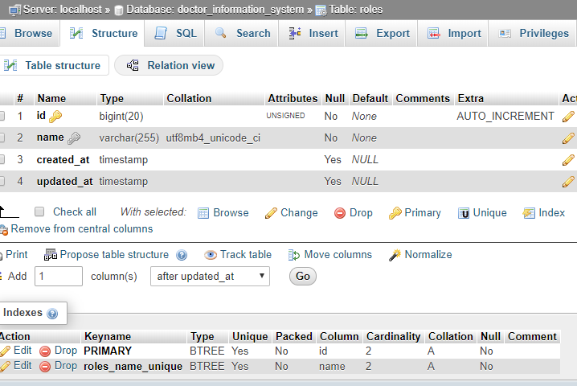

sliders table

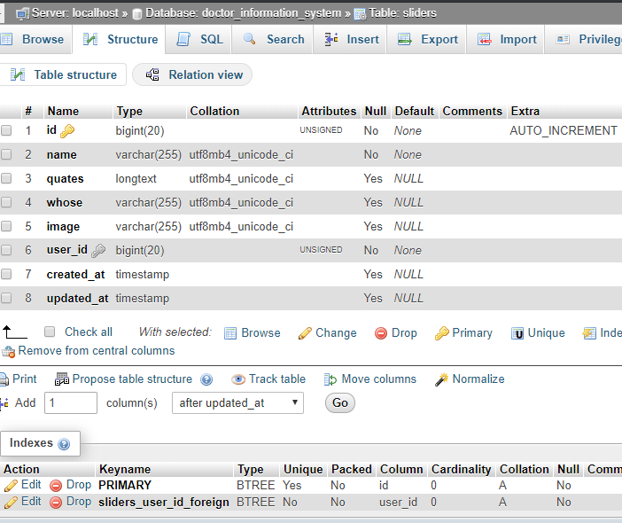

Users table

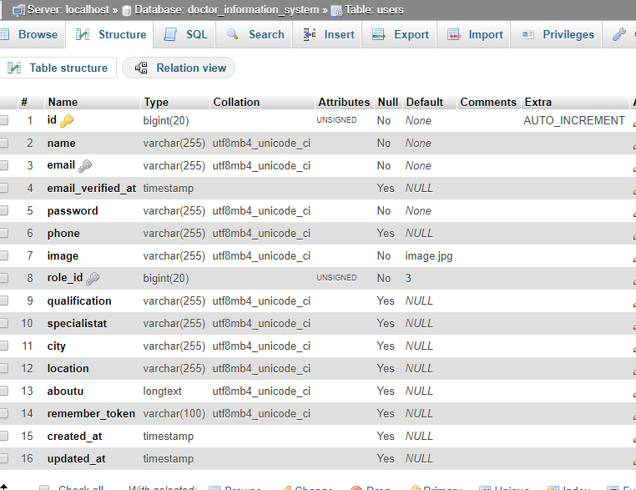

### 3.3.2 Entity Relationship Diagram

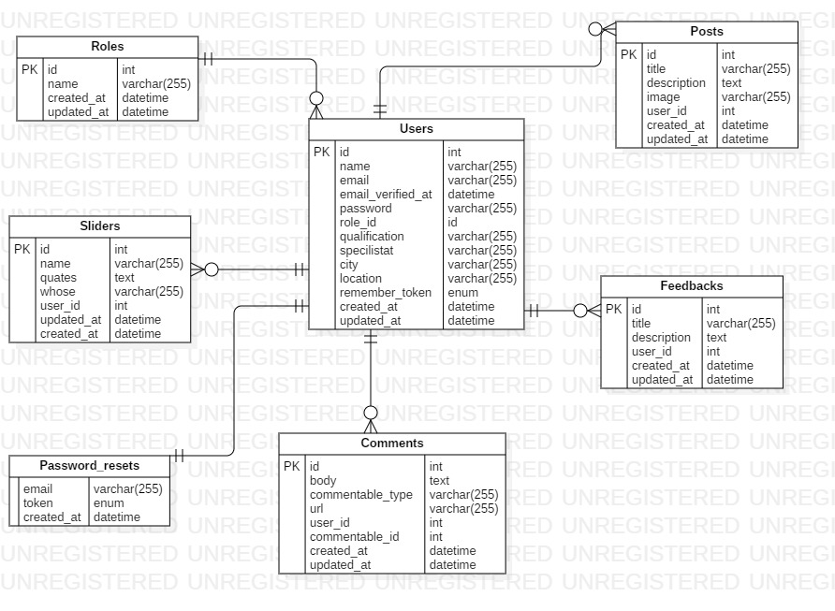

3.4 User Interface Modeling

### 3.4.1 Prototypes

I have used digital prototyping tool named balsamiq for making the prototype. Digital Prototype is creating the sample how the system will look like using some digital tool (software). It is part of UI modeling.

Reason for choosing balsamiq

* Open source
* Easy to use
* Available
* Reliable
* Provides icons quicker from the search

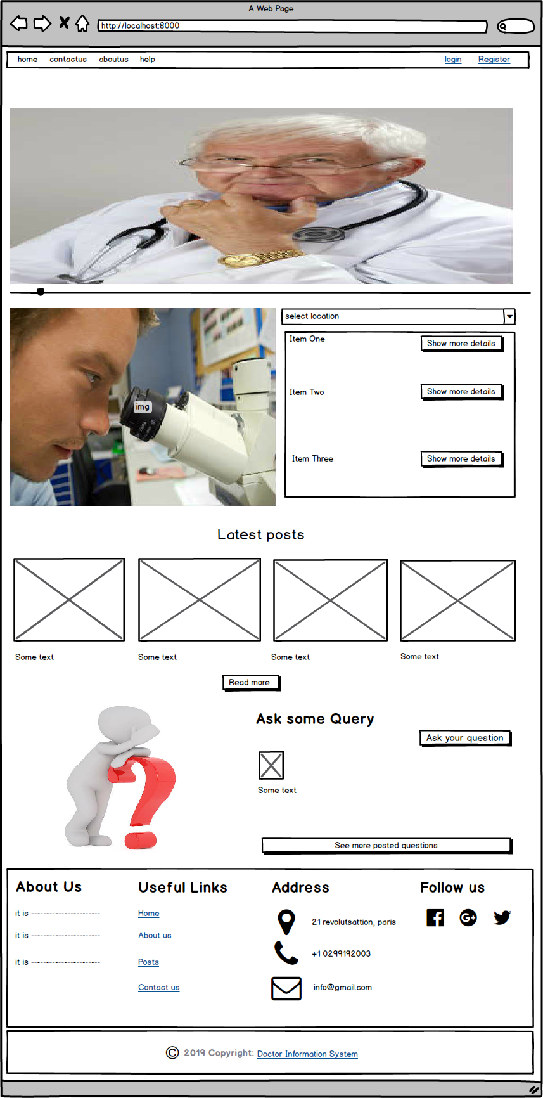

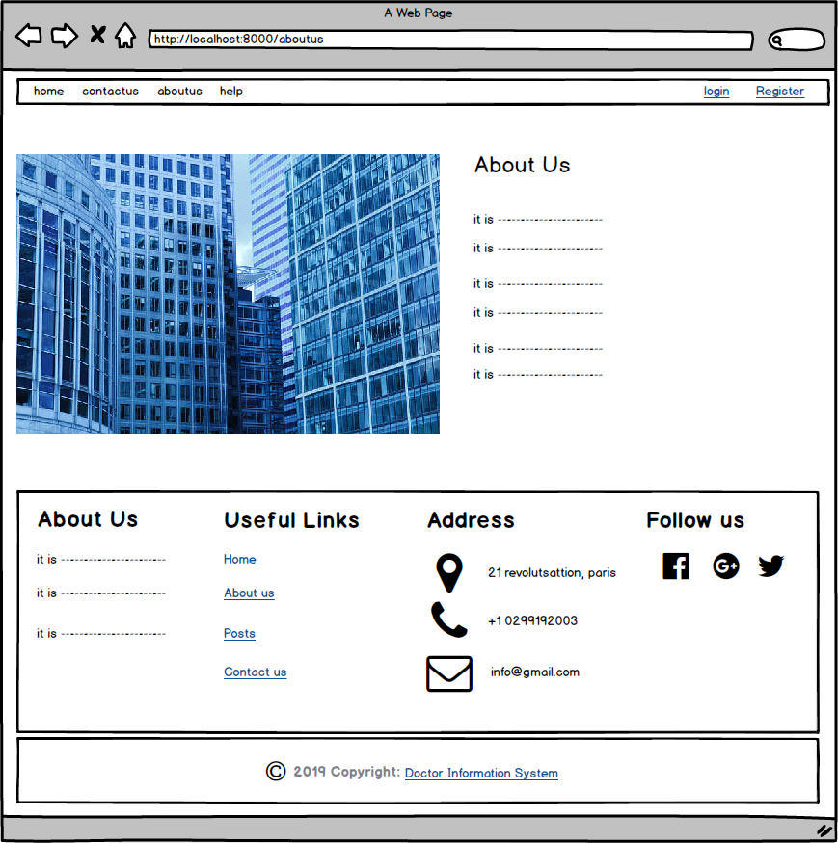

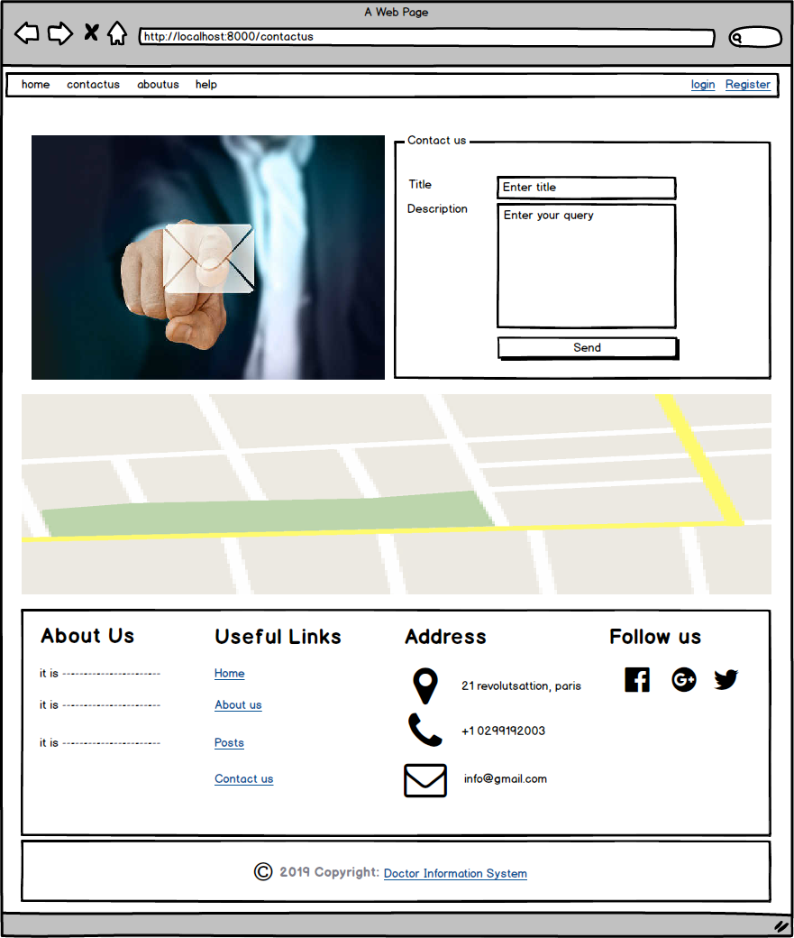

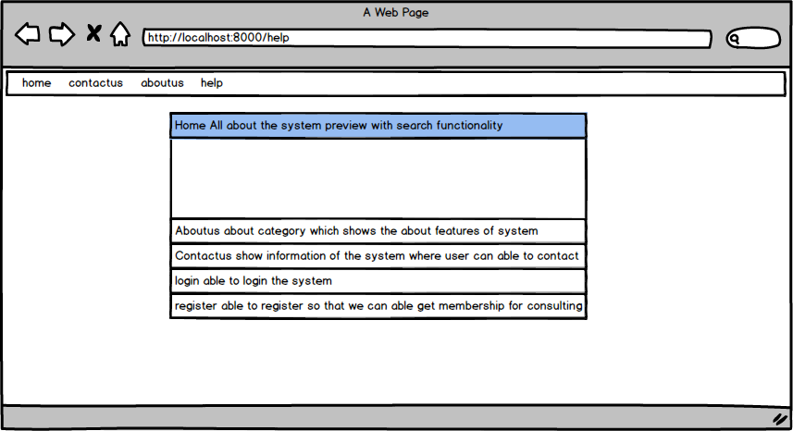

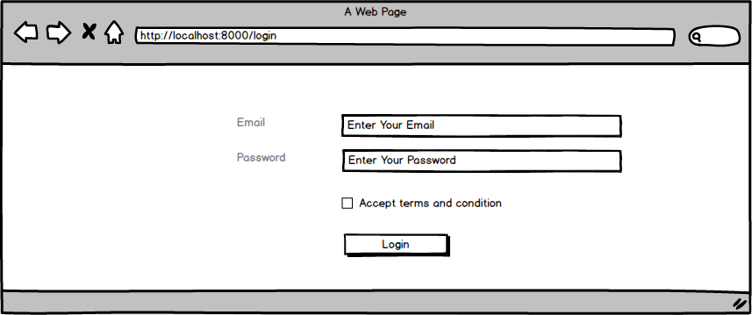

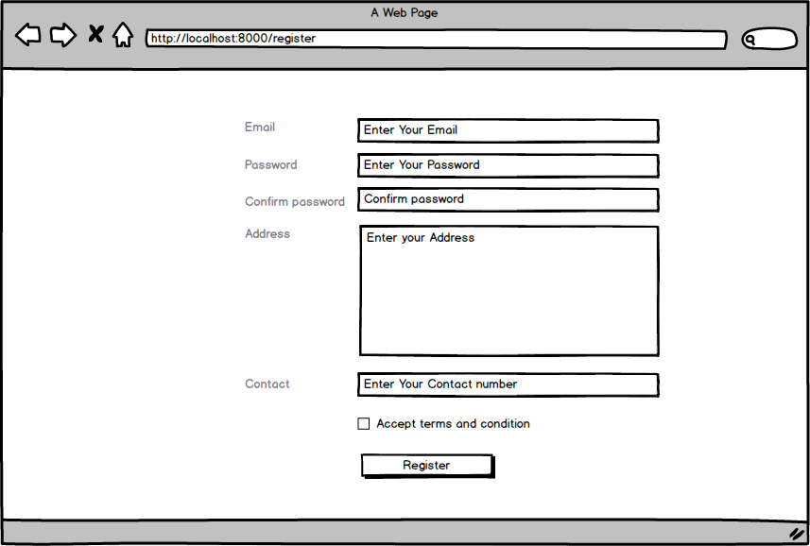

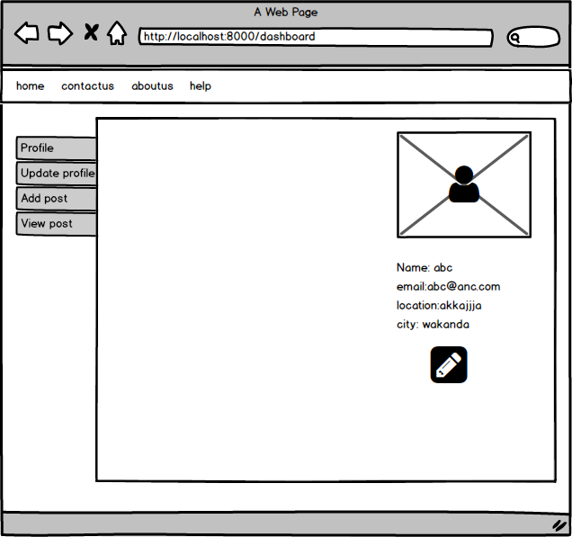

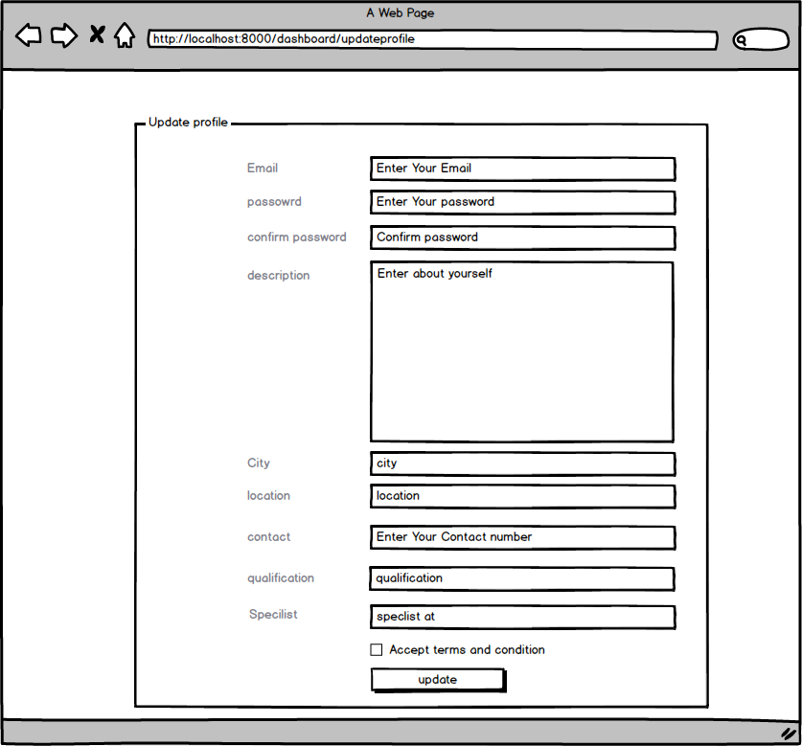

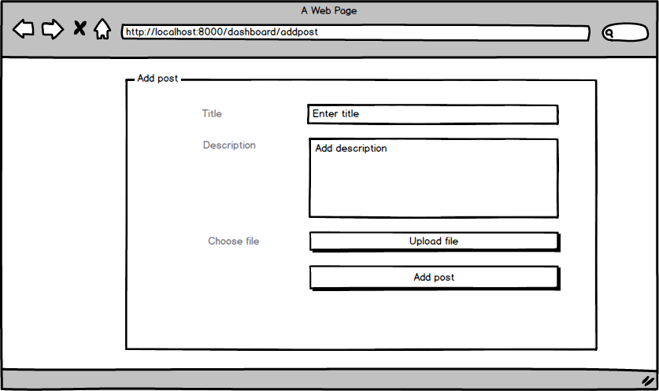

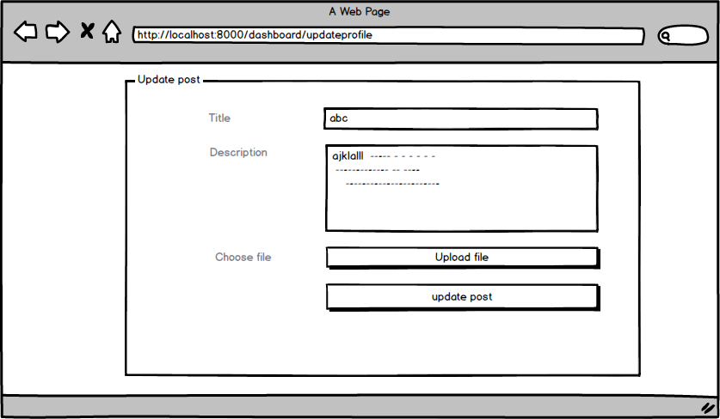

# Chapter 5 Testing

Testing is the process of finding errors or checking whether the product works as its aspect to do that functionality or task. It tests whether it meets the user requirements. It is process of verifying or identifying errors or faults in the system.

There are different methods or process of testing

* Black box testing
* White box testing

## 5.1 Black box testing:

It may be performed by the user which does not have more knowledge of programming. It checks the functionality not with code logic of code written. It checks whether the input and output expected match or not.

Black box testing techniques are given below:

* **Equivalent testing:**

This is performed when there is similar type of values to test and test cases which helps to save time and money. Similar types of test are grouped and perform one of them for testing.

* **Boundary testing:**

This is performed to check the boundary values whether the certain range of values are acceptable or not. It is mostly suitable for the those test whose test have within ranges of values.

* **Decision table testing:**

It is used to perform to test conditional statement or switch statement function testing.

Some black box testing performed for this application are mention below:

### Login for admin:

|  |  |  |  |  |  |  |
| --- | --- | --- | --- | --- | --- | --- |
| **Test Case**  **ID** | **Test Scenario** | **Test Description** | **Test Data** | **Expected Result** | **Actual Result** | **Status** |
| T001LoginAdmin | Login validation | Without email and password | Email=””  Password=”” | Login failed message email required | Login failed message email required | pass |
| T002loginAdmin | Login validation | With email but not password | Email=[admin@admin.com](mailto:admin@admin.com)  Password=”” | Login failed message password required | Login failed message password required | pass |
| T003loginAdmin | Login validation | With invalid email and admin right password for admin | Email=[sujel@gmail.com](mailto:sujel@gmail.com)  Password=” admin123” | Message These credentials do not match our record | Message These credentials do not match our record | Pass |
| T004loginAdmin | Verification | Provide valid email and password | Email=[admin@admin.com](mailto:admin@admin.com)  Password=” admin123” | Display dashboard with user profile | Display dashboard with user profile | Pass |

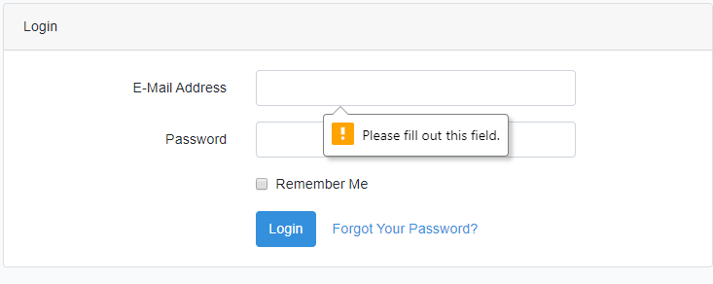

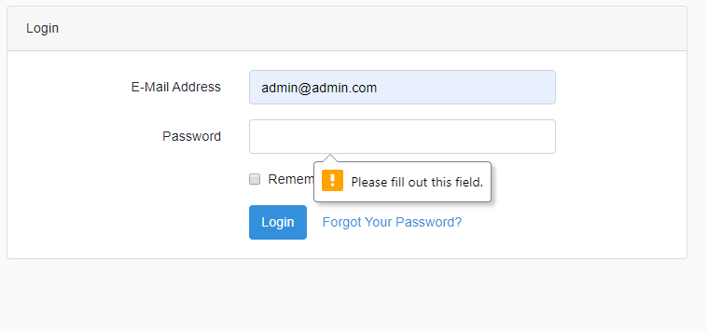

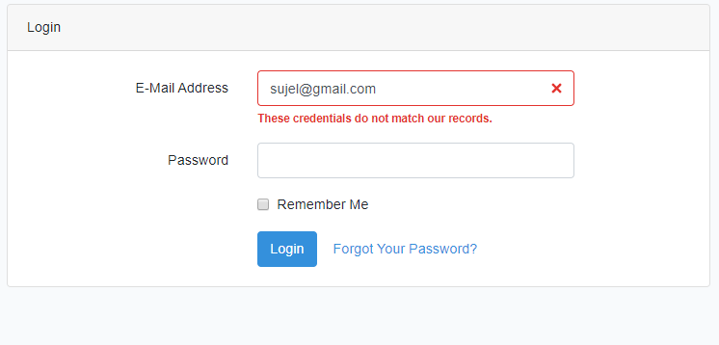

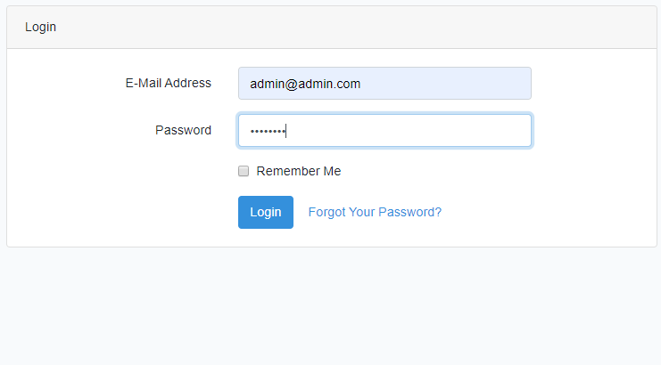

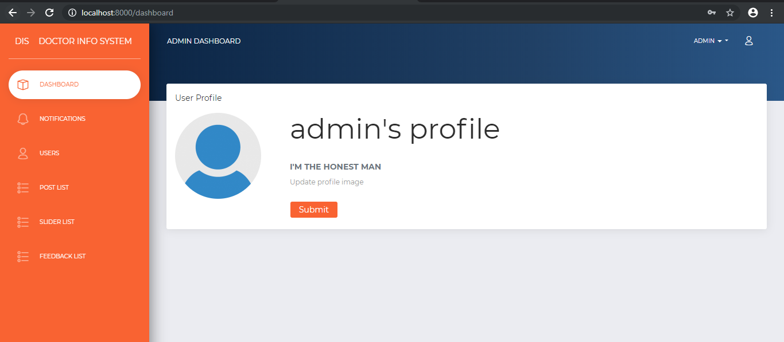

### Login Attempt:

|  |  |  |  |  |  |  |
| --- | --- | --- | --- | --- | --- | --- |
| **Test case id** | **Test scenario** | **Test description** | **Test data** | **Expected result** | **Actual result** | **Status** |
| T005loginattempt | Verification | Provide right email but password wrong | Email=[admin@admin.com](mailto:admin@admin.com)  Password=” amen12345” | Message These credentials do not match our record | Message These credentials do not match our record | Pass |
| T006loginattempt | verification | Provide wrong password for 2 time | Email=[admin@admin.com](mailto:admin@admin.com)  Password=” jahir123” | Message These credentials do not match our record | Message These credentials do not match our record | Pass |
| T007loginattempt | verification | Provide wrong password for 3 time | Email=[admin@admin.com](mailto:admin@admin.com)  Password=” johncean997” | Message These credentials do not match our record | Message These credentials do not match our record | Pass |
| T008loginattempt | verification | Provide wrong password for 4 time | Email=[admin@admin.com](mailto:admin@admin.com)  Password=” sethfreakingrollens” | Message too many logins attempt please try in 157 seconds | Message too many logins attempt please try in 157 seconds | Pass |

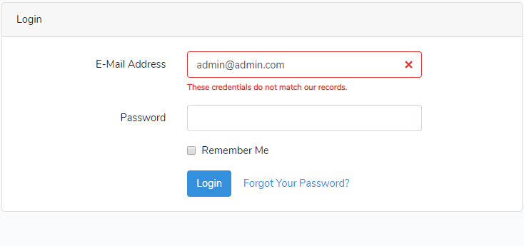

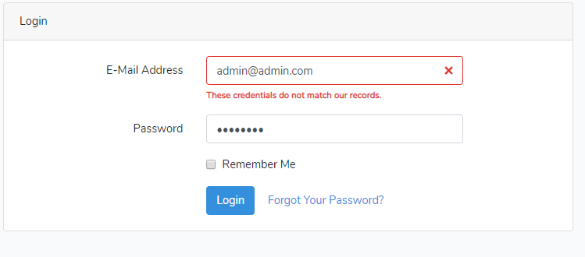

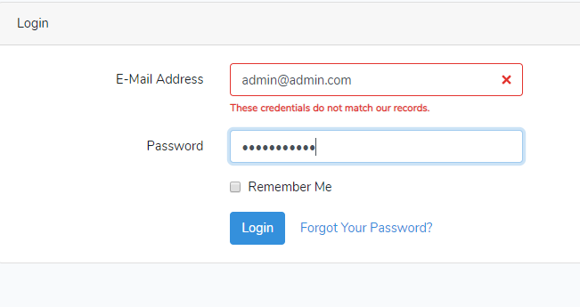

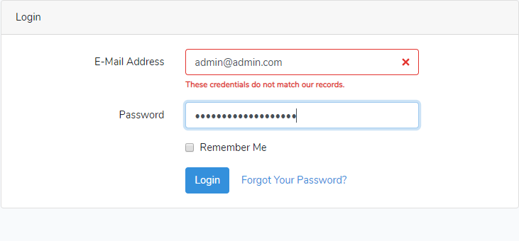

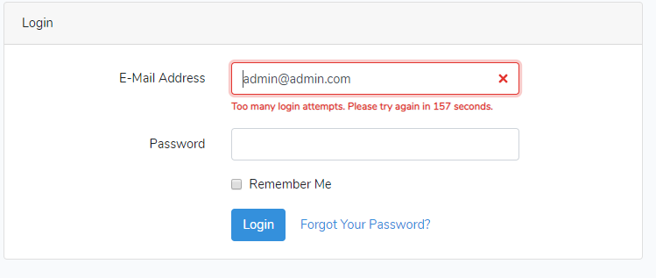

### Create post:

|  |  |  |  |  |  |  |
| --- | --- | --- | --- | --- | --- | --- |
| **Test case id** | **Test scenario** | **Test description** | **Test data** | **Expected result** | **Actual result** | **Status** |
| T009createpost | Validation of field required | Click on submit without providing any field | Title=””  Description=””  Image=”” | Message title required | Message title required | Pass |
| T010createpost | Validation of field required | Provided title only | Title=”blood pressure”  Description=””  Image=”” | Message description required | Message description required | Pass |
| T011createpost | Validation of field required | Provided title and description but not image | Title=” blood pressure”  Description=” we can control blood pressure by doing light exercise”  Image=”” | Message image required | Message image required | Pass |
| T011createpost | Validation of field required | Provided all fields | Title=” blood pressure”  Description=” we can control blood pressure by doing light exercise”  Image=” tee-3809474_640.jpg” | Message successfully added post | Message successfully added post | Pass |

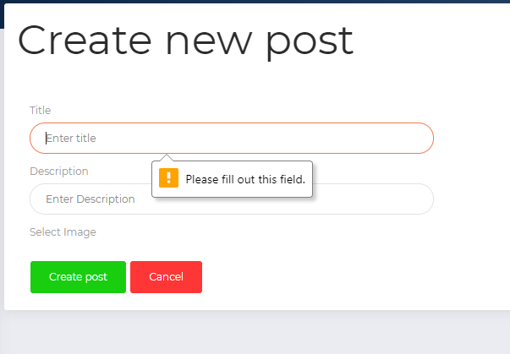

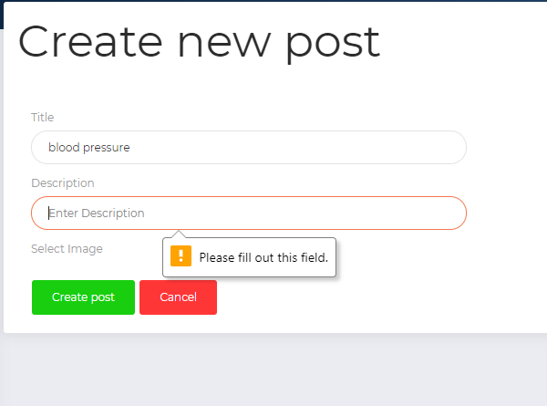

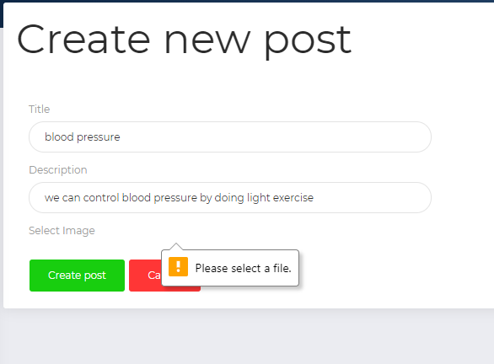

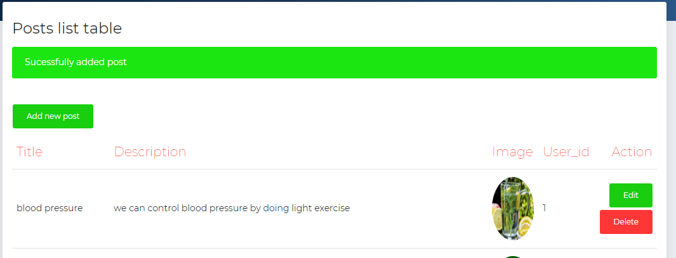

### Update post

|  |  |  |  |  |  |  |
| --- | --- | --- | --- | --- | --- | --- |
| **Test case id** | **Test scenario** | **Test description** | **Test data** | **Expected result** | **Actual result** | **Status** |
| T013updatepost | Changes the descriptions | Make changes in only description | Title=” blood pressure”  Description=” we control blood pressure by eating healthy diet “image=”” | Message updated successfully | Message updated successfully | Pass |
| T014updatepost | Changes the descriptions and images | Make changes in description and image | Title=” blood pressure”  Description=” we control blood pressure by eating healthy diet “image=” eat-2834549_640.jpg” | Message updated successfully | Message updated successfully | Pass |

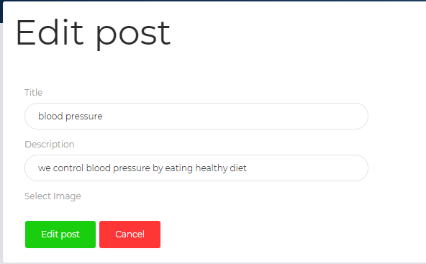

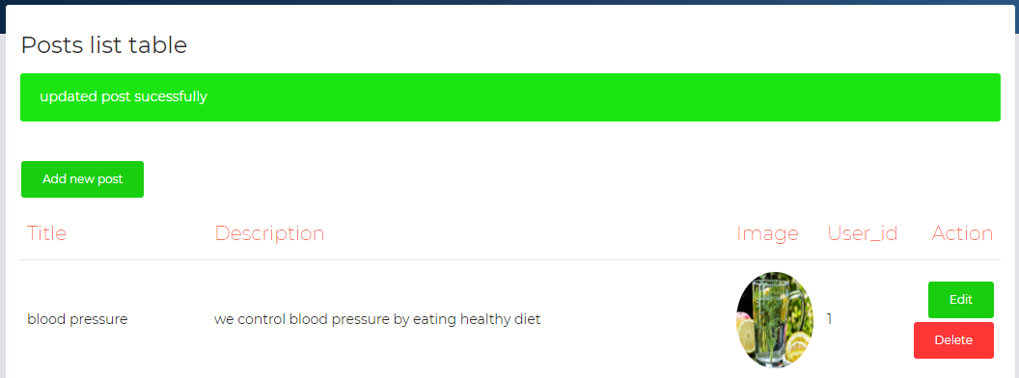

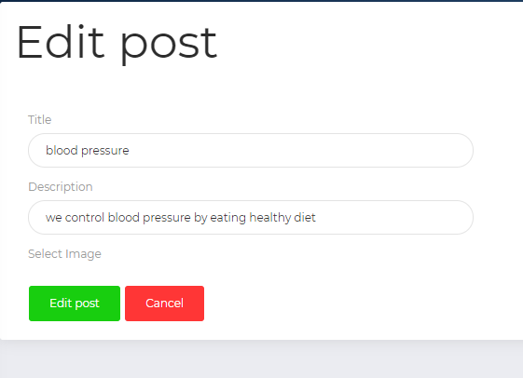

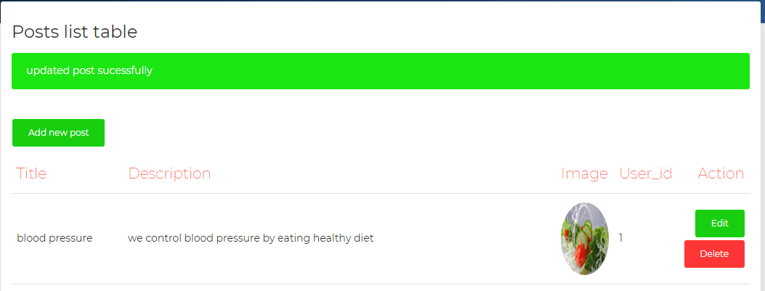

### Delete post

|  |  |  |  |  |  |  |
| --- | --- | --- | --- | --- | --- | --- |
| **Test case id** | **Test scenario** | **Test description** | **Test data** | **Expected result** | **Actual result** | **Status** |
| T015deletepost | confirmation | Click on delete and select cancel | Confirmation  cancel | Return to post index page | Return to post index page | Pass |
| T016deletepost | confirmation | Click on delete and select delete | Confirmation  Yes | Return to post index page with successfully delete post | Return to post index page with successfully delete post | Pass |

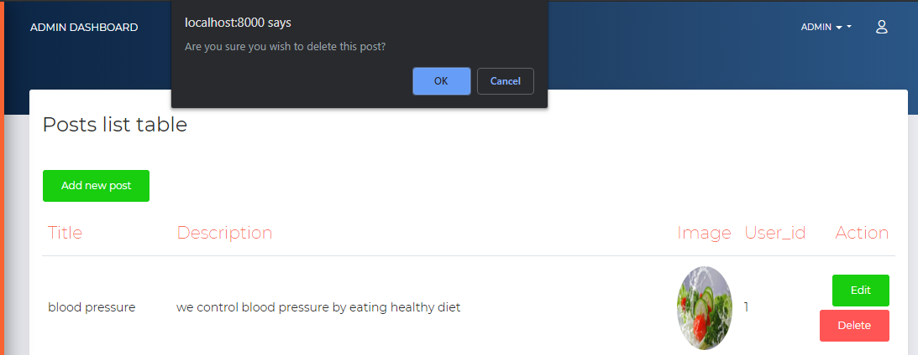

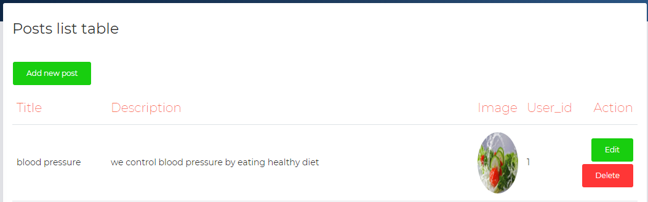



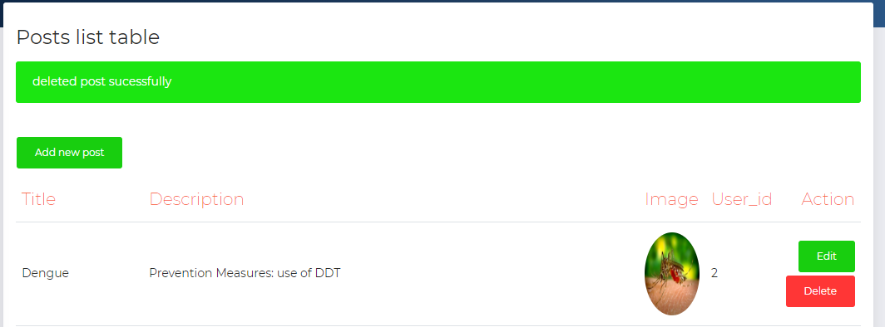

|  |  |  |  |  |  |  |
| --- | --- | --- | --- | --- | --- | --- |
| **Test case id** | **Test scenario** | **Test description** | **Test data** | **Expected result** | **Actual result** | **Status** |
| T017reguser | Validation | Without input all field | Email=”” password=””  Confirm password=”” and other too | Message error for required field | Message error for required field | Pass |
| T018reguser | Validation | Field all require field but password only 5 character | Email=[fahad@gmail.com](mailto:fahad@gmail.com)  password=” Fahad”  Confirm password=”” and other similarly | Message error for password must be 8 character | Message error for password must be 8 character | Pass |
| T019reguser | Validation | Field all require field but password confirmation and password different | Email=[fahad@gmail.com](mailto:fahad@gmail.com) password=” fahad123”  Confirm password=” Fahad” and other too | Message error for password should match with confirm password | Message error for password should match with confirm password | Pass |
| T020reguser | Validation | Filled all field properly | Email=[fahad@gmail.com](mailto:fahad@gmail.com) password=” fahad123”  Confirm password=” fahad123” and other too | View the home page  With profile | View the home page  with profile | Pass |

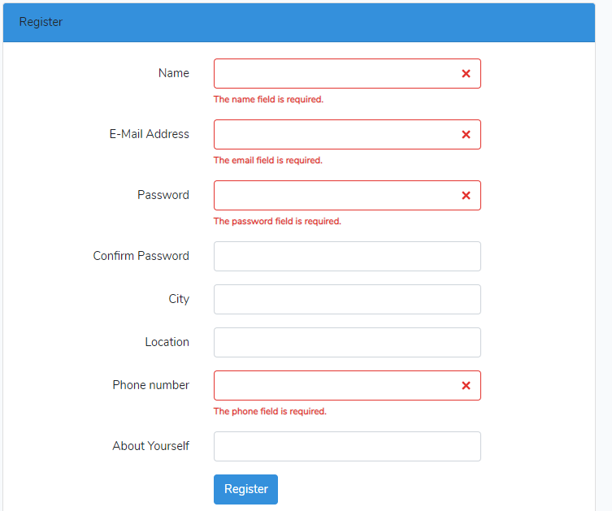

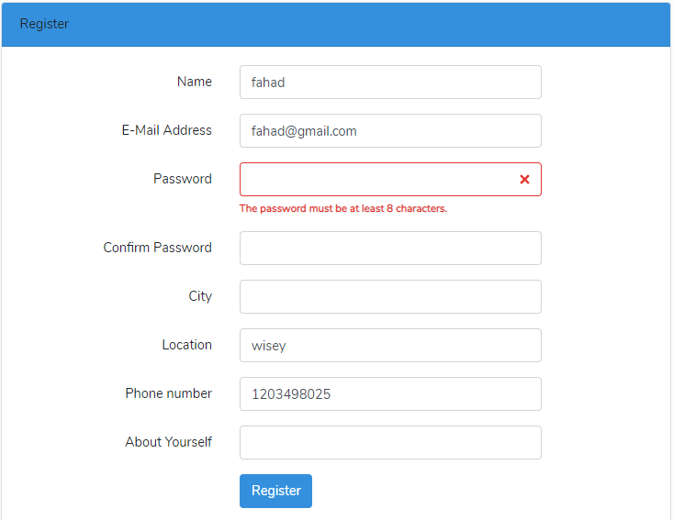

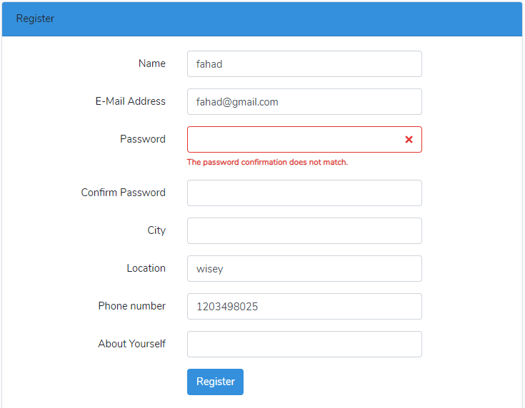

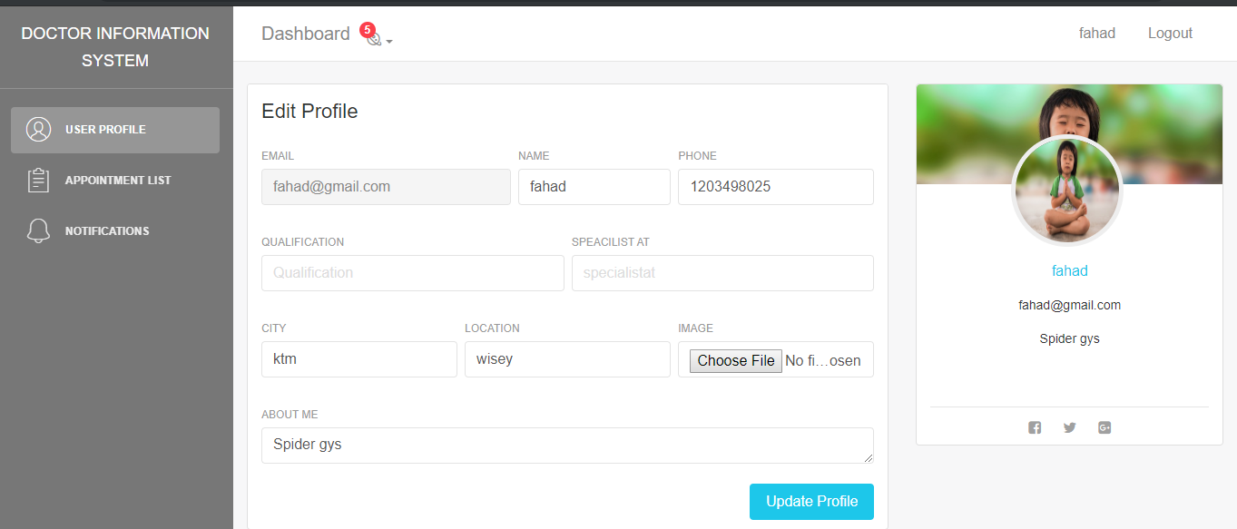

### Provide feedback

|  |  |  |  |  |  |  |
| --- | --- | --- | --- | --- | --- | --- |
| **Test case id** | **Test scenario** | **Test description** | **Test data** | **Expected result** | **Actual result** | **Status** |
| T021feedback | Validation of field | Click on submit empty all field | Title=””  Description=”” | Message filled title required | Message filled title required | Pass |
| T022feedback | Validation of field | Filled only title | Title=” home page”  Description=”” | Message filled title required | Message filled title required | Pass |
| T023feedback | Validation of field | Filled all filed | Title=” home page”  Description=” homepage must somewhat colorful” | Message thank you for your feedback | Message thank you for your feedback | Pass |

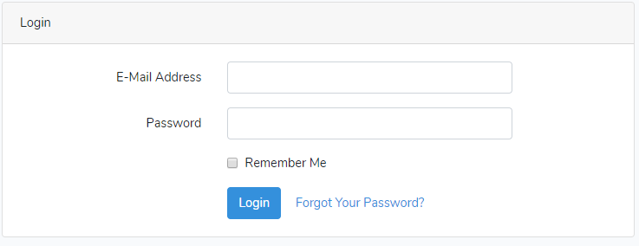

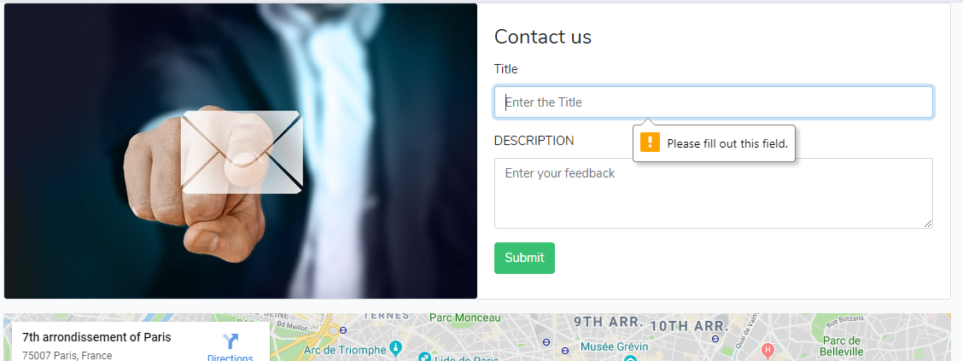

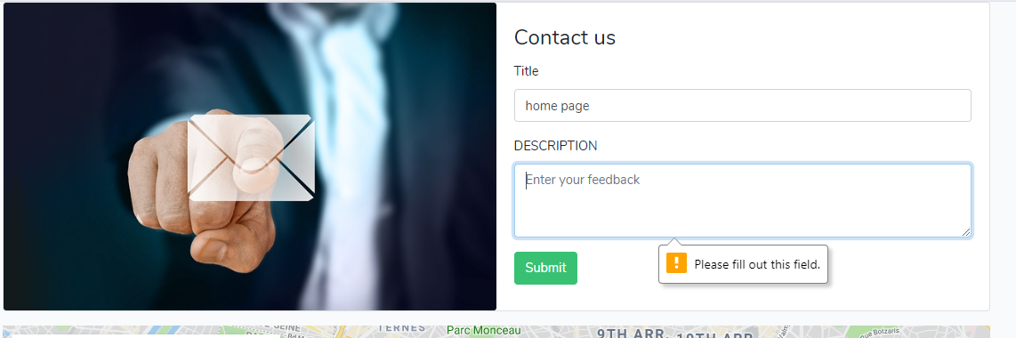

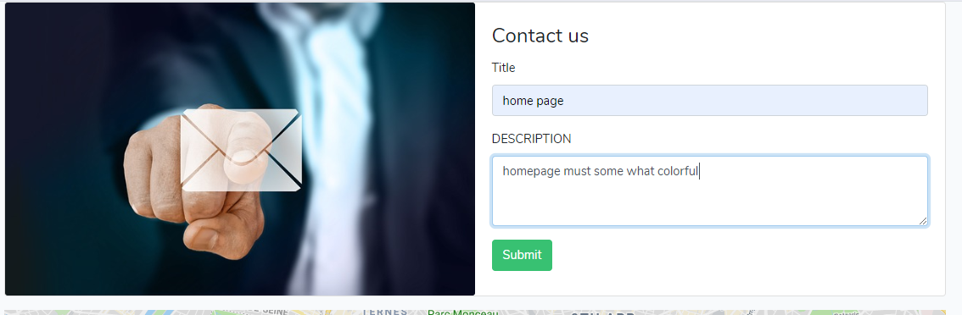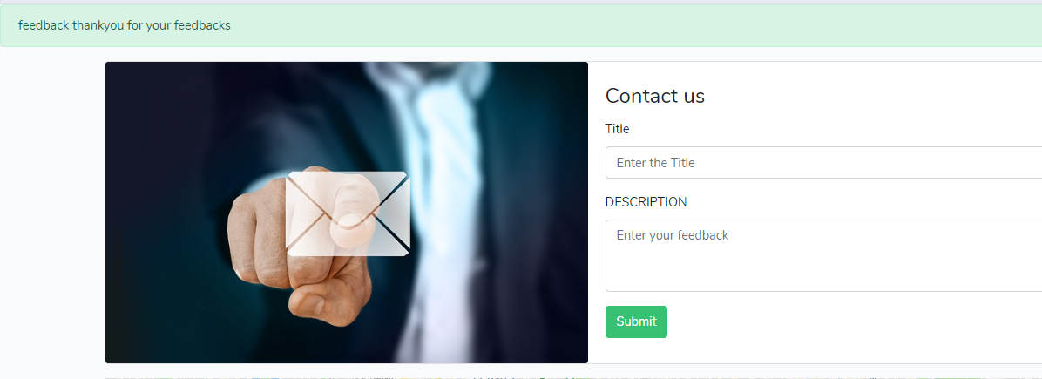

### Make appointment:

|  |  |  |  |  |  |  |
| --- | --- | --- | --- | --- | --- | --- |
| **Test case id** | **Test scenario** | **Test description** | **Test data** | **Expected result** | **Actual result** | **Status** |
| T024appointment | Check for login | Without login click on make appointment | Click on make appointment | Redirect to login page | Redirect to login page | Pass |
| T025appointment | Validation of field | Login and click submit without providing any detail | Title=””  Datetime=”” | Message title not filled | Message title not filled | Pass |
| T026appointment | Validation of field | Provide title for appointment | Title=”blood pressure checkup”  Datetime=”” | Message time not selected | Message time not selected | Pass |
| T027appointment | Validation of field | Provide time and appointment title | Title=”blood pressure checkup”  Datetime=”9/30/2019 5:30 PM” | Message successfully made appointment | Message successfully made appointment | Pass |



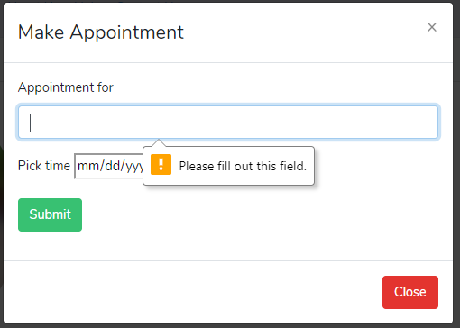

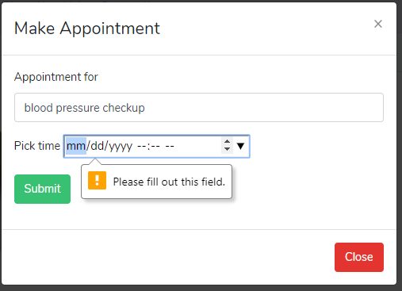

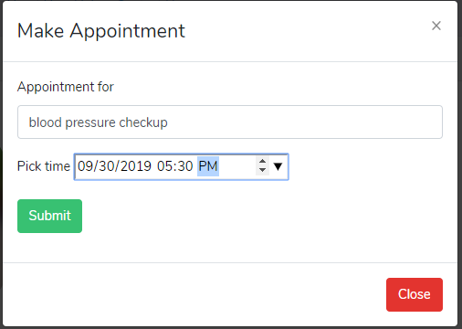



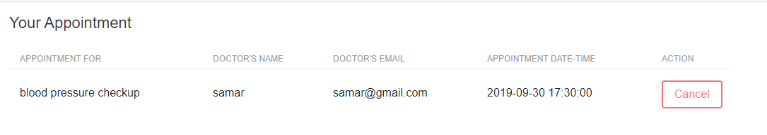

### Add review:

|  |  |  |  |  |  |  |
| --- | --- | --- | --- | --- | --- | --- |
| **Test case id** | **Test scenario** | **Test description** | **Test data** | **Expected result** | **Actual result** | **Status** |
| T028rating | Check for login user | Click on add review without login | Without login try to add review | Redirect to login page | Redirect to login page | Pass |
| T029rating | Validate the field for making review | Click on star but not add review description | Stars=”5”  Description=”” | Message filled empty | Message filled empty | Pass |
| T030rating | Validate the field for making review | Provide both stars and review description | Stars=”5”  Review=” awesome” | Message successfully added review | Message successfully added review | Pass |



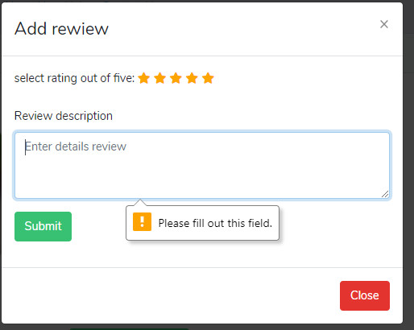

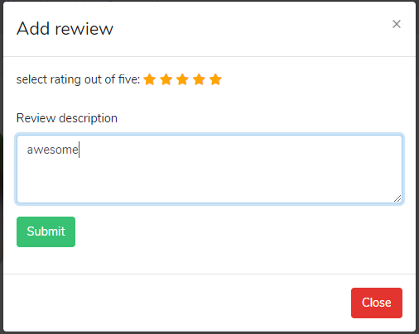

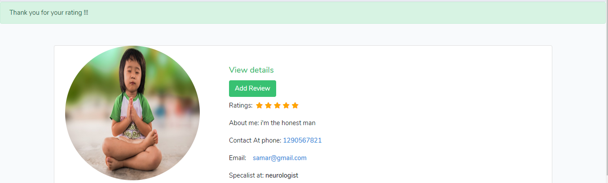

## 5.2 White box testing:

It is performed by tester having knowledge of programming. It mainly focuses on the logic of application. It is not only concerned with expected and actual output of the system. It symbolizes ability to see through the outer shell to inner code of the system.

There is different level of white box testing which are given below:

* Unit testing
* Integrated testing
* System testing

### 5.2.1 Unit testing:

Unit testing may be defined as the level of white box testing in which every function is check individually whether the functionality/method perform as expected to work. Unit test for this application are mention below:

#### Welcome page unit testing:

**Test ID: T031welcomepage**

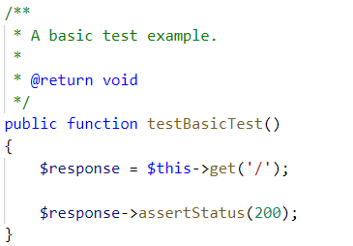

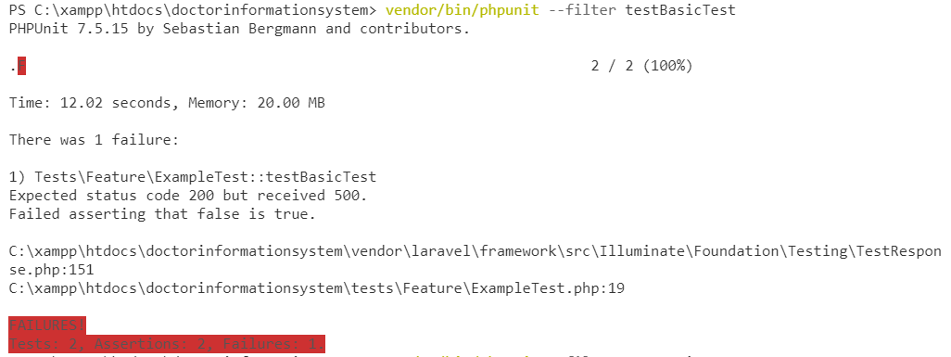

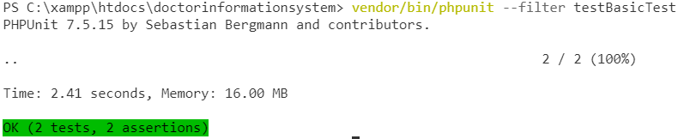

#### Redirect to login

**Test ID: T032redirecttologin**

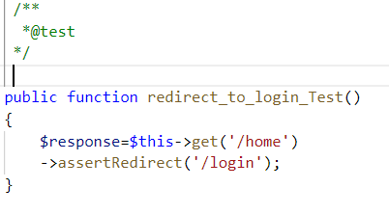

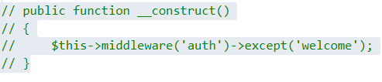

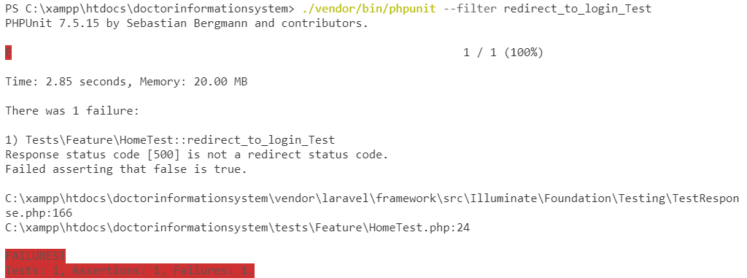

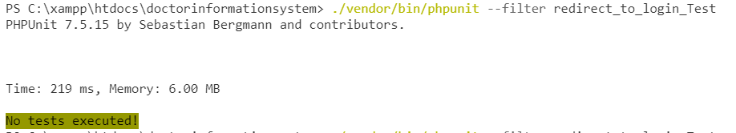

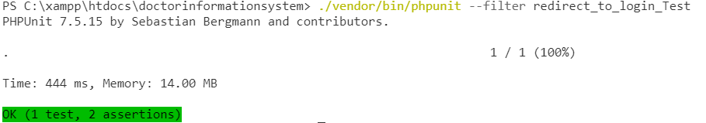

#### Unit test for login authentication to visit login page:

**Test ID: T032registernewuser**

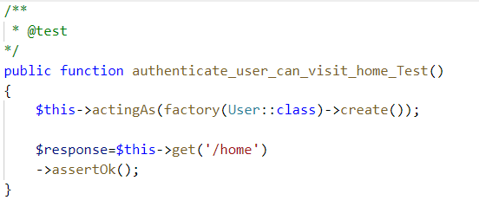

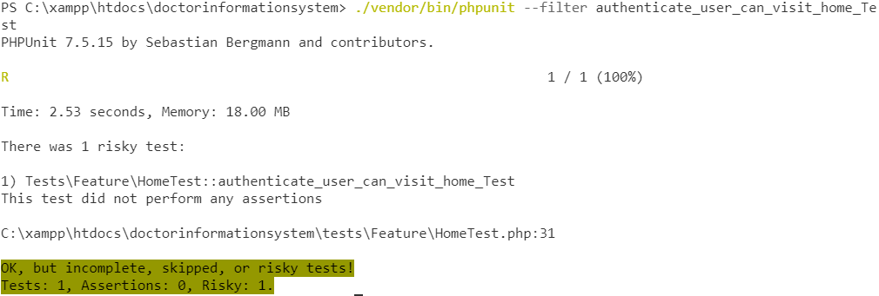

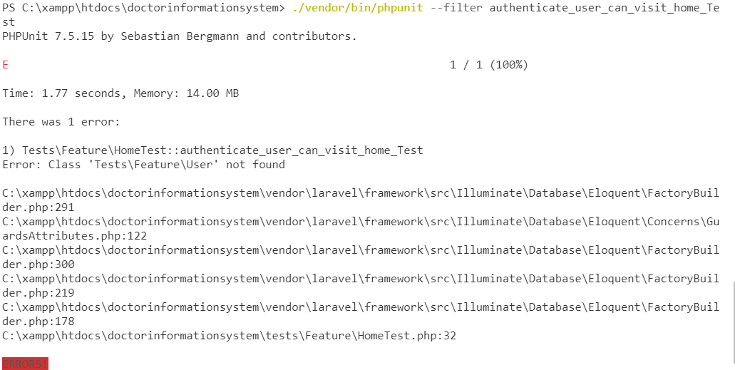



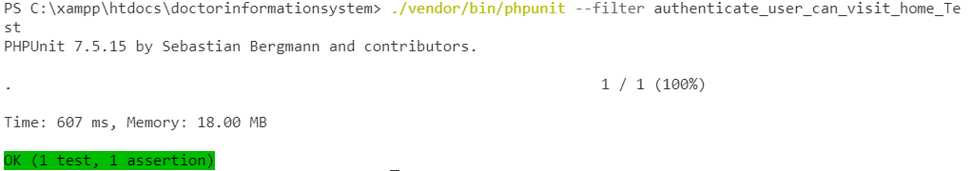

#### Unit test for contact us page view

**Test ID: T033contactus**

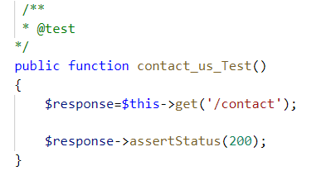

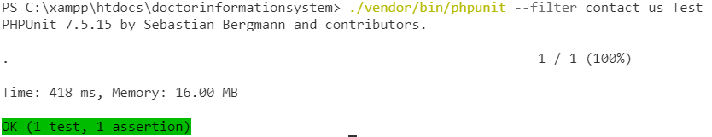

#### Unit test for about us page view

**Test ID: T034aboutus**

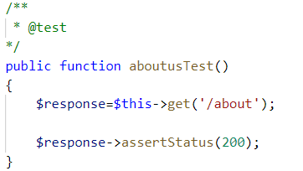

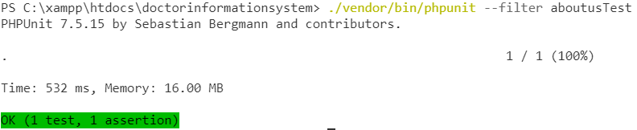

#### Unit test for store post

**Test ID: T035storepost**

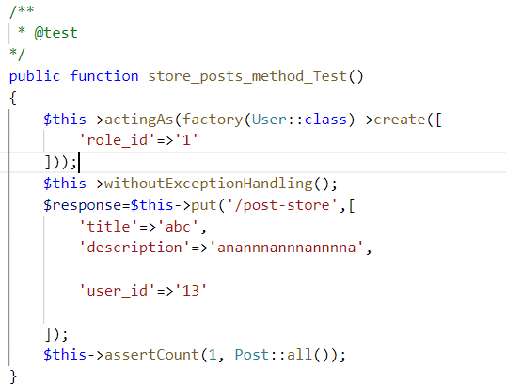

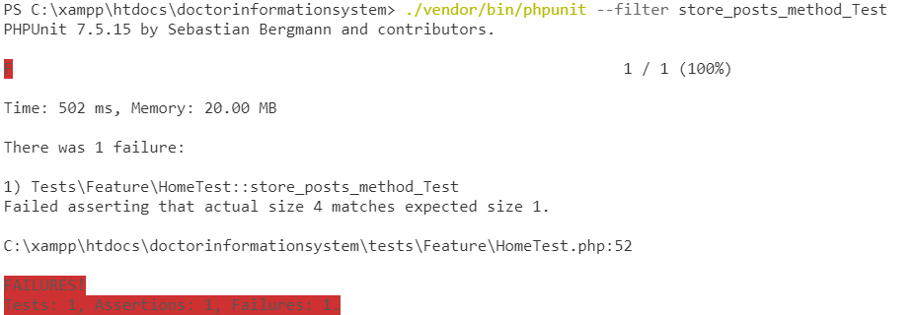

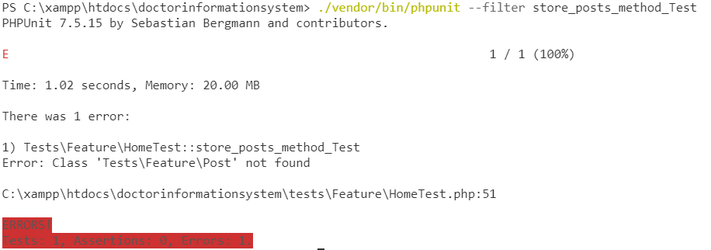

### 5.2.2 Integrated testing:

It is level of white box testing in which methods are tested integrating two or more methods to check whether it function well after integrating the methods. In this testing ensures the correctness of the interface of application and performed in open environment.

### 5.2.3 Regression testing:

It is the testing level in which testing is performed after the changes of code to confirm the change code has not adversely affected existing features of code. It usually performed when requirement changes which lead to change the code, defect fixing, performance issue fixing.

# Chapter 6: Other project issues

## 6.1 Limitation

Anything which I cannot able to complete in this project is known as the limitation of this project. There is some limitation of this project which are mention below:

* Unable to perform Agile methodology
* Unable to do some post method unit testing of the program
* Unable to perform test driven development

## 6.2 Future works

Anything that I will like to add in this project in future fall under the future works. There are some future works that I will like to add in this program are given below:

* Integrate secure online payment system so that user can able to pay securely for consulting the doctor.
* Add to get membership for online consulting
* Integrate video call consulting in the system so that user can show the report to the doctor and consult their problem and doctor can provide good advice to the patient easily.

## 6.3 Risk management

Risk is situation that can impact our project negatively. In other word, anything that can expose towards the danger is risk. Risk management deals with managing, identifying, controlling the threats or risks of the project. But here we can say while implementing the programming what are the real risk that we have face in our project. Some of the risks that we have faced during this project are mention below:

* Time management:
* Less knowledge of the Laravel framework
* Unit testing
* Choosing right tool for prototype designing
* Choose right tool for designing other designing aspect
* Right Implementation

## 6.4 Configuration management:

Configuration management may be defined as process of identifying, and track individual configuration item, documentation of functional capabilities, and interdependences. In simple words, configuration management is process of show how the files and folder are related with each other and what will happen when any changes made. It is managing the file and folder.

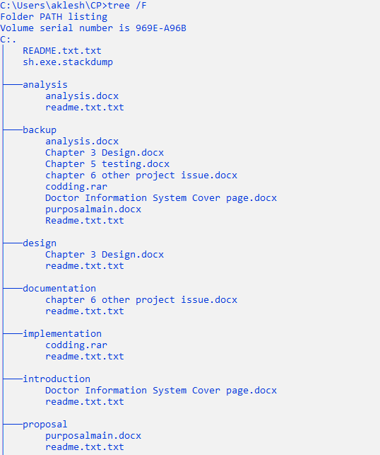

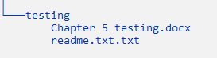

## 6.5 User manual:

User manual is some sorts of guideline and instruction provided to the users so that it makes easy to use system. It outlines the information of system and how to use it.

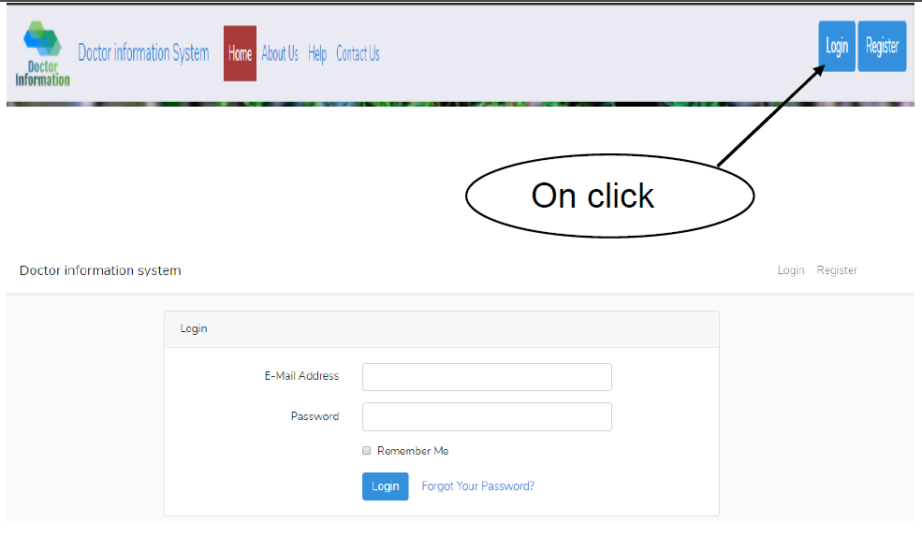

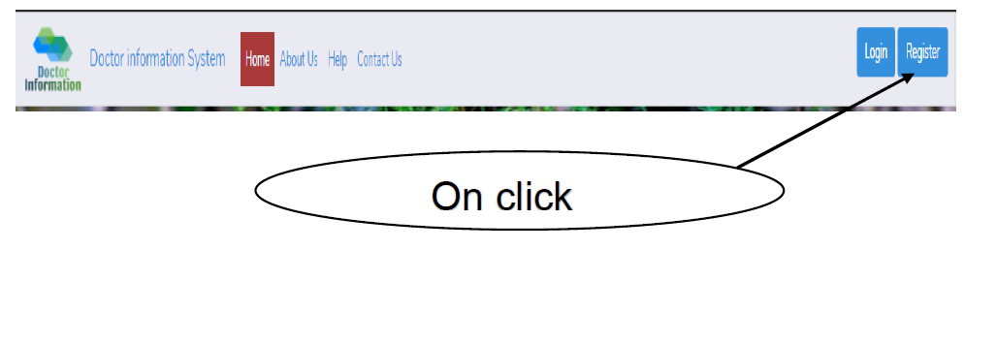

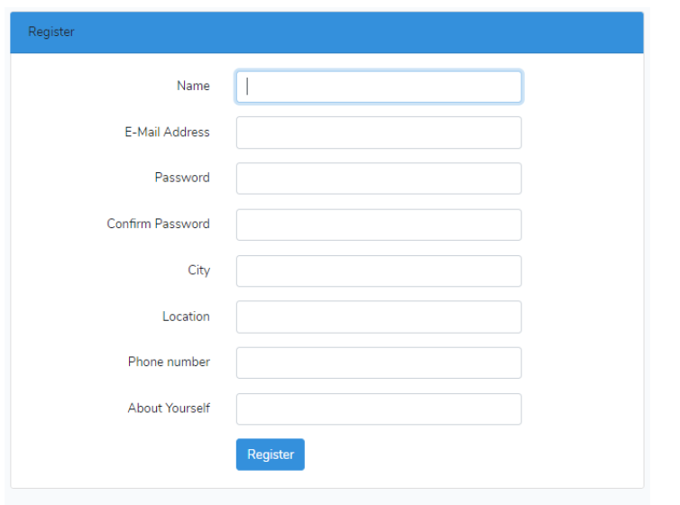

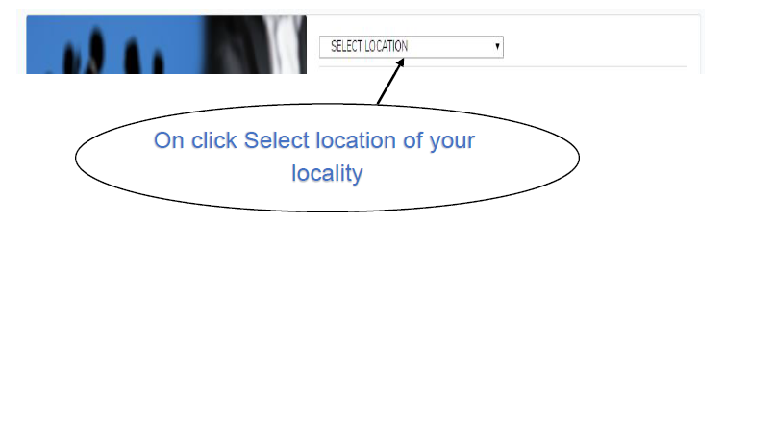

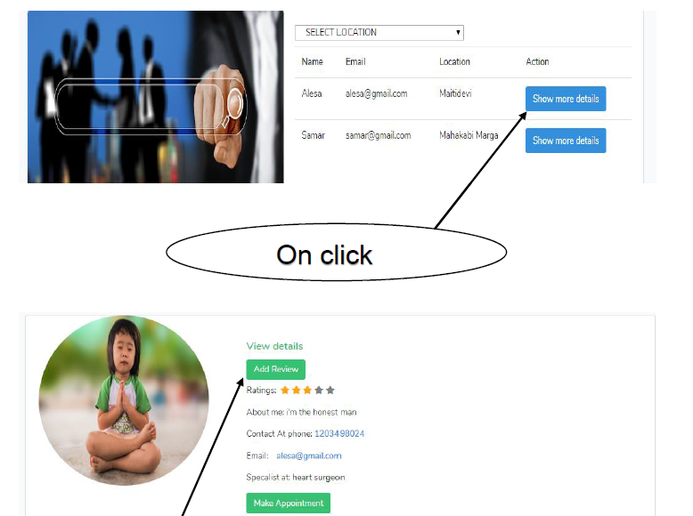

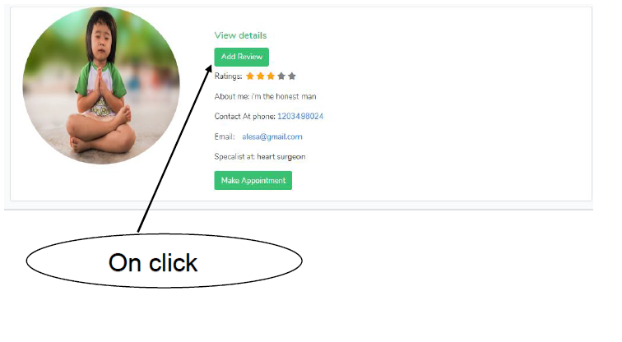

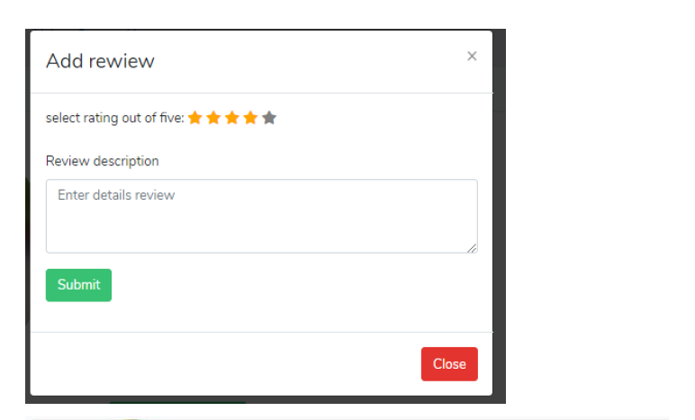

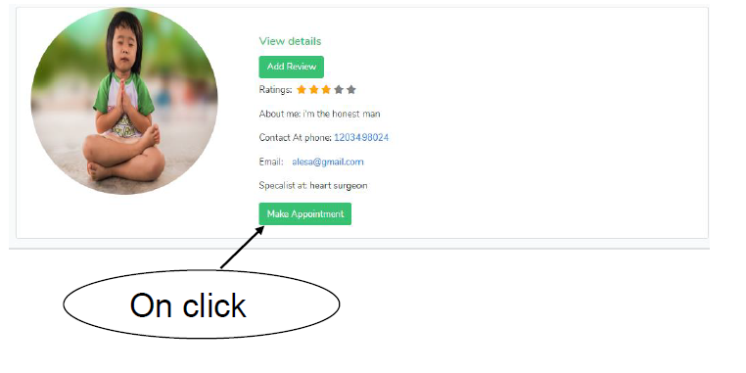

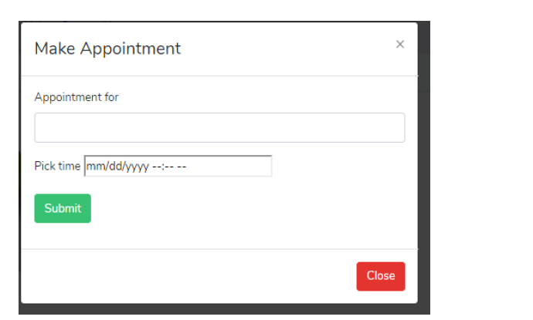

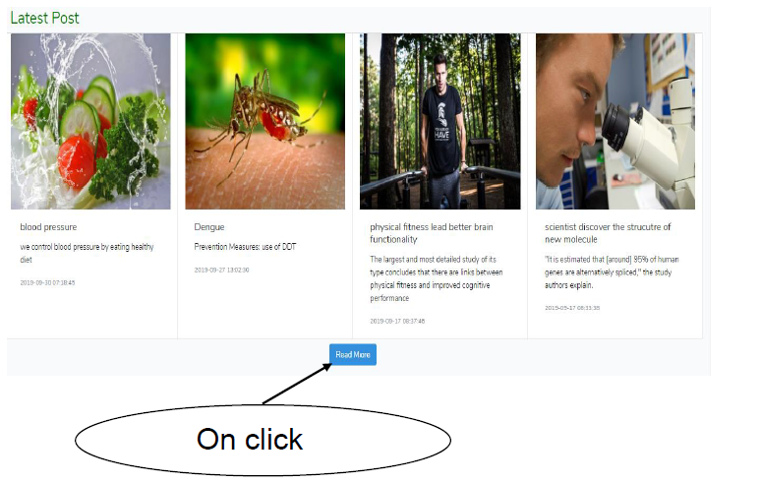

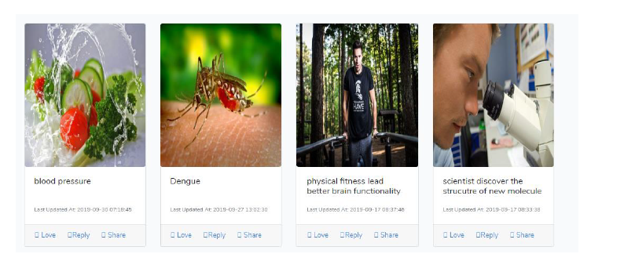

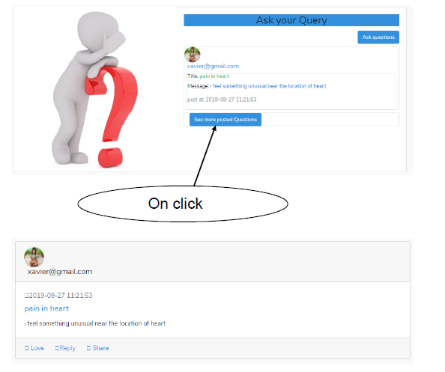

# Conclusion

I have completed all the must have and should have features and some of the could have features that are enlisted in the analysis portion of the project. Here user can login easily and provide feedback. If they have some health-related issues, they can be able post their query. Other users as well as doctor can add comment on that message post. Doctor and admin can able to add posts and able to perform CRUD operations. Doctor can only delete and update the post that they had posted.

All user can register as normal user and only admin can updated their role. All three types of user have different authority. Users could be able to update their profile. Users could make appoint with doctors. And provide review to the doctor after the treatment. I have approximately done all the documentation parts of this project as well as implementation portion.